Mobile Application Development Lab Record

Name: Riya Ganesh Shanbhag
Registration No.: 230953058
Branch: Computer & Communication Engineering (CCE)
Batch: D1
Roll No.: 8

Lab 1: BASICS OF ANDROID MOBILE APPLICATION DEVELOPMENT TOOL

Q1: Create an Android application to show the demo of displaying text with justifying elements, changing text colors ,fonts etc.

MainActivity.java:
package com.example.demo;

import android.graphics.Color;
import android.graphics.Typeface;
import android.os.Bundle;
import android.view.View;
import android.widget.TextView;
import androidx.appcompat.app.AppCompatActivity;

public class MainActivity extends AppCompatActivity {

TextView textView;
float currentSize = 18f;

@Override
protected void onCreate(Bundle savedInstanceState) {
super.onCreate(savedInstanceState);
setContentView(R.layout.activity_main);

textView = findViewById(R.id.textView);
}

public void makeRed(View view) {
textView.setTextColor(Color.RED);
}

public void makeBlue(View view) {
textView.setTextColor(Color.BLUE);
}

public void makeBold(View view) {
textView.setTypeface(null, Typeface.BOLD);
}

public void makeItalic(View view) {
textView.setTypeface(null, Typeface.ITALIC);
}

public void increaseSize(View view) {
currentSize += 2;
textView.setTextSize(currentSize);
}
}

activity_main.xml:
<?xml version="1.0" encoding="utf-8"?>
<LinearLayout xmlns:android="http://schemas.android.com/apk/res/android"
android:layout_width="match_parent"
android:layout_height="match_parent"
android:orientation="vertical"
android:padding="16dp">

<TextView
android:id="@+id/textView"
android:layout_width="match_parent"
android:layout_height="wrap_content"
android:text="Demo Text"
android:textSize="18sp"
android:padding="8dp"
android:justificationMode="inter_word"/>

<Button
android:id="@+id/redBtn"
android:layout_width="match_parent"
android:layout_height="wrap_content"
android:text="Make Text Red"
android:onClick="makeRed"/>

<Button
android:id="@+id/blueBtn"
android:layout_width="match_parent"
android:layout_height="wrap_content"
android:text="Make Text Blue"
android:onClick="makeBlue"/>

<Button
android:id="@+id/boldBtn"
android:layout_width="match_parent"
android:layout_height="wrap_content"
android:text="Bold Text"
android:onClick="makeBold"/>

<Button
android:id="@+id/italicBtn"
android:layout_width="match_parent"
android:layout_height="wrap_content"
android:text="Italic Text"
android:onClick="makeItalic"/>

<Button
android:id="@+id/increaseSizeBtn"
android:layout_width="match_parent"
android:layout_height="wrap_content"
android:text="Increase Text Size"
android:onClick="increaseSize"/>

</LinearLayout>

UI:
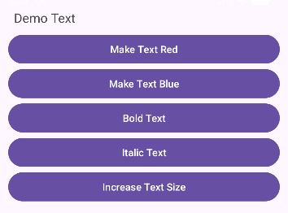
After changing the text size and the text color:
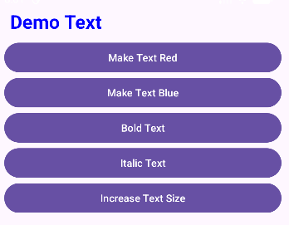
Q2: Find the “hello word” text in the XML document and modify the text.

MainActivity.java:
package com.example.demo;

import android.os.Bundle;
import androidx.appcompat.app.AppCompatActivity;

public class MainActivity extends AppCompatActivity {

@Override
protected void onCreate(Bundle savedInstanceState) {
super.onCreate(savedInstanceState);
setContentView(R.layout.activity_main);
}
}

activity_main.xml:
<?xml version="1.0" encoding="utf-8"?>
<androidx.constraintlayout.widget.ConstraintLayout xmlns:android="http://schemas.android.com/apk/res/android"
xmlns:app="http://schemas.android.com/apk/res-auto"
xmlns:tools="http://schemas.android.com/tools"
android:layout_width="match_parent"
android:layout_height="match_parent"
android:padding="16dp">

<TextView
android:layout_width="wrap_content"
android:layout_height="wrap_content"
android:layout_marginStart="148dp"
android:layout_marginTop="248dp"
android:layout_marginEnd="117dp"
android:layout_marginBottom="448dp"
android:text="Welcome to My App!"
app:layout_constraintBottom_toBottomOf="parent"
app:layout_constraintEnd_toEndOf="parent"
app:layout_constraintStart_toStartOf="parent"
app:layout_constraintTop_toTopOf="parent" />

</androidx.constraintlayout.widget.ConstraintLayout>

UI:
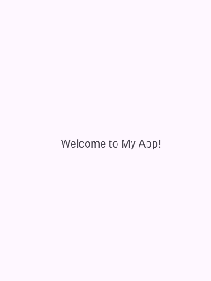

Lab 2: INTRODUCTION TO ACTIVITY AND LAYOUTS IN ANDROID

Q1: Create an app that illustrates that the activity lifecycle method being triggered by various action. Understand when onCreate(),onStart(),onResume event occur

MainActivity.java:
package com.example.demo;

import android.os.Bundle;
import android.widget.Toast;
import androidx.appcompat.app.AppCompatActivity;

public class MainActivity extends AppCompatActivity {

@Override
protected void onCreate(Bundle savedInstanceState) {
super.onCreate(savedInstanceState);
setContentView(R.layout.activity_main);
Toast.makeText(this, "onCreate() called", Toast.LENGTH_SHORT).show();
}

@Override
protected void onStart() {
super.onStart();
Toast.makeText(this, "onStart() called", Toast.LENGTH_SHORT).show();
}

@Override
protected void onResume() {
super.onResume();
Toast.makeText(this, "onResume() called", Toast.LENGTH_SHORT).show();
}
}

activity_main.xml:
<?xml version="1.0" encoding="utf-8"?>
<LinearLayout xmlns:android="http://schemas.android.com/apk/res/android"
android:layout_width="match_parent"
android:layout_height="match_parent"
android:gravity="center"
android:orientation="vertical">

<TextView
android:id="@+id/textView"
android:layout_width="wrap_content"
android:layout_height="wrap_content"
android:text="Activity Lifecycle Demo"
android:textSize="20sp"/>

</LinearLayout>

UI:
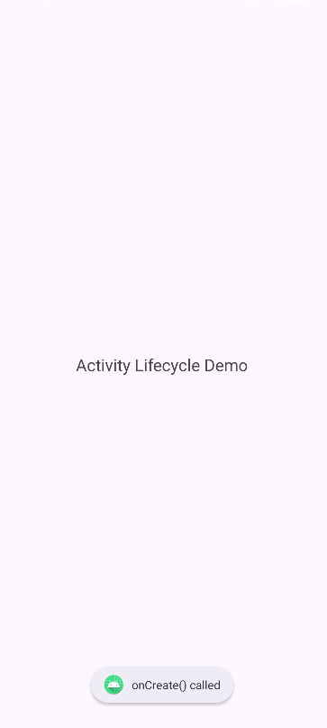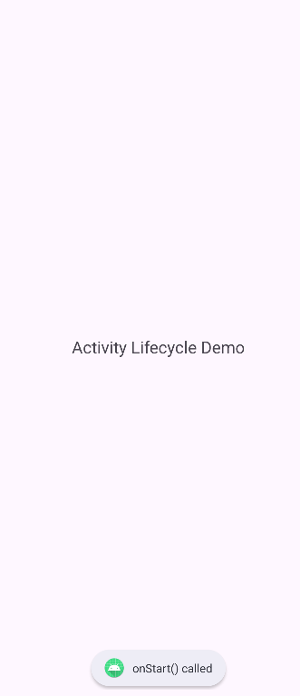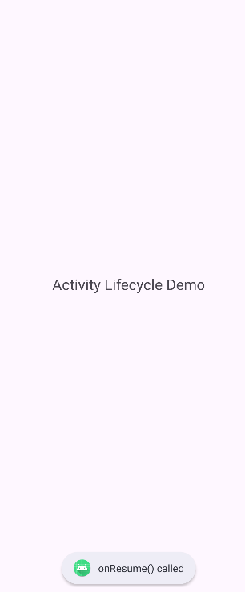

Q2: Create a Calculator app that does the function of multiplication, addition, division, subtraction but displays the result in the format of:-Num1 operator num2 = result. Back button on the next activity should get back to the calculator activity again.

MainActivity.java:
package com.example.demo;

import android.content.Intent;
import android.os.Bundle;
import android.view.View;
import android.widget.Button;
import android.widget.TextView;
import androidx.appcompat.app.AppCompatActivity;

import com.example.demo.ResultActivity;

public class MainActivity extends AppCompatActivity {

TextView display;
String num1 = "", num2 = "", operator = "";
boolean isSecondNumber = false;

@Override
protected void onCreate(Bundle savedInstanceState) {
super.onCreate(savedInstanceState);
setContentView(R.layout.activity_main);

display = findViewById(R.id.display);
}

public void onDigitClick(View view) {
Button btn = (Button) view;
if (!isSecondNumber) {
num1 += btn.getText().toString();
display.setText(num1);
} else {
num2 += btn.getText().toString();
display.setText(num2);
}
}

public void onOperatorClick(View view) {
Button btn = (Button) view;
operator = btn.getText().toString();
isSecondNumber = true;
}

public void onClearClick(View view) {
num1 = num2 = operator = "";
isSecondNumber = false;
display.setText("0");
}

public void onEqualClick(View view) {
if (num1.isEmpty() || num2.isEmpty()) return;

Intent intent = new Intent(this, ResultActivity.class);
intent.putExtra("num1", num1);
intent.putExtra("num2", num2);
intent.putExtra("operator", operator);
startActivity(intent);
}
}

activity_main.xml:
<?xml version="1.0" encoding="utf-8"?>
<LinearLayout xmlns:android="http://schemas.android.com/apk/res/android"
android:layout_width="match_parent"
android:layout_height="match_parent"
android:orientation="vertical"
android:padding="12dp">
<TextView
android:layout_width="match_parent"
android:layout_height="wrap_content"
android:text="Calculator"
android:textAlignment="center"
android:textSize="30sp"/>

<TextView
android:id="@+id/display"
android:layout_width="match_parent"
android:layout_height="50dp"
android:background="#DDDDDD"
android:gravity="end|center_vertical"
android:padding="10dp"
android:textSize="28sp"
android:text="0"/>

<GridLayout
android:layout_width="match_parent"
android:layout_height="wrap_content"
android:columnCount="4"
android:rowCount="5"
android:layout_marginTop="10dp">

<Button android:text="7" android:onClick="onDigitClick"/>
<Button android:text="8" android:onClick="onDigitClick"/>
<Button android:text="9" android:onClick="onDigitClick"/>
<Button android:text="÷" android:onClick="onOperatorClick"/>

<Button android:text="4" android:onClick="onDigitClick"/>
<Button android:text="5" android:onClick="onDigitClick"/>
<Button android:text="6" android:onClick="onDigitClick"/>
<Button android:text="×" android:onClick="onOperatorClick"/>

<Button android:text="1" android:onClick="onDigitClick"/>
<Button android:text="2" android:onClick="onDigitClick"/>
<Button android:text="3" android:onClick="onDigitClick"/>
<Button android:text="-" android:onClick="onOperatorClick"/>

<Button android:text="0" android:onClick="onDigitClick"/>
<Button android:text="C" android:onClick="onClearClick"/>
<Button android:text="=" android:onClick="onEqualClick"/>
<Button android:text="+" android:onClick="onOperatorClick"/>

</GridLayout>

</LinearLayout>

ResultAcitivity.java:
package com.example.demo;

import android.os.Bundle;
import android.widget.TextView;
import androidx.appcompat.app.AppCompatActivity;

public class ResultActivity extends AppCompatActivity {

@Override
protected void onCreate(Bundle savedInstanceState) {
super.onCreate(savedInstanceState);
setContentView(R.layout.activity_result);

TextView resultText = findViewById(R.id.resultText);

double n1 = Double.parseDouble(getIntent().getStringExtra("num1"));
double n2 = Double.parseDouble(getIntent().getStringExtra("num2"));
String op = getIntent().getStringExtra("operator");

double result = 0;
switch (op) {
case "+": result = n1 + n2; break;
case "-": result = n1 - n2; break;
case "×": result = n1 * n2; break;
case "÷": result = n2 != 0 ? n1 / n2 : 0; break;
}

resultText.setText(n1 + " " + op + " " + n2 + " = " + result);
}
}

activity_result.xml:
<?xml version="1.0" encoding="utf-8"?>
<LinearLayout xmlns:android="http://schemas.android.com/apk/res/android"
android:layout_width="match_parent"
android:layout_height="match_parent"
android:gravity="center"
android:orientation="vertical">

<TextView
android:id="@+id/resultText"
android:layout_width="wrap_content"
android:layout_height="wrap_content"
android:textSize="26sp"
android:textStyle="bold"/>

</LinearLayout>

UI:
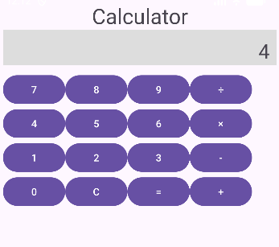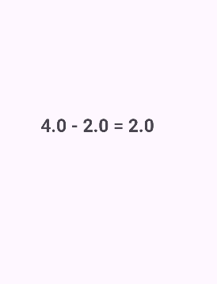

Q3: Create the following given scenario using linear and relative layout concept.
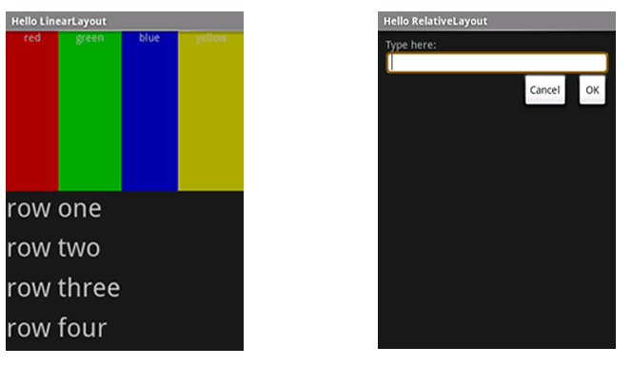
Linear Layout:

MainActivity.java:
package com.example.demo;

import android.os.Bundle;
import androidx.appcompat.app.AppCompatActivity;

public class MainActivity extends AppCompatActivity {

@Override
protected void onCreate(Bundle savedInstanceState) {
super.onCreate(savedInstanceState);
setContentView(R.layout.activity_main);
}
}

activity_main.xml:
<?xml version="1.0" encoding="utf-8"?>
<LinearLayout xmlns:android="http://schemas.android.com/apk/res/android"
android:layout_width="match_parent"
android:layout_height="match_parent"
android:orientation="vertical">
<TextView
android:layout_width="match_parent"
android:layout_height="wrap_content"
android:text="Hello Linear Layout"
android:textSize="20sp"
android:background="#8C000000"
android:textColor="@color/white" />

<LinearLayout
android:layout_width="match_parent"
android:layout_height="281dp"
android:orientation="horizontal">

<TextView
android:layout_width="0dp"
android:layout_height="match_parent"
android:layout_weight="1"
android:background="#FF0000"
android:textAlignment="center"
android:text="red"
android:textColor="#FFFFFF" />

<TextView
android:layout_width="0dp"
android:layout_height="match_parent"
android:layout_weight="1"
android:background="#00FF00"
android:textAlignment="center"
android:text="green"
android:textColor="#FFFFFF" />

<TextView
android:layout_width="0dp"
android:layout_height="match_parent"
android:layout_weight="1"
android:background="#0000FF"
android:textAlignment="center"
android:text="blue"
android:textColor="#FFFFFF" />

<TextView
android:layout_width="0dp"
android:layout_height="match_parent"
android:layout_weight="1"
android:background="#FFFF00"
android:textAlignment="center"
android:text="yellow"
android:textColor="#FFFFFF" />
</LinearLayout>

<LinearLayout
android:layout_width="match_parent"
android:layout_height="match_parent"
android:background="#222222"
android:orientation="vertical"
android:padding="16dp">

<TextView
android:layout_width="match_parent"
android:layout_height="0dp"
android:layout_weight="1"
android:text="row one"
android:textSize="22sp"
android:textColor="#FFFFFF"/>

<TextView
android:layout_width="match_parent"
android:layout_height="0dp"
android:layout_weight="1"
android:text="row two"
android:textSize="22sp"
android:textColor="#FFFFFF"/>

<TextView
android:layout_width="match_parent"
android:layout_height="0dp"
android:layout_weight="1"
android:text="row three"
android:textSize="22sp"
android:textColor="#FFFFFF"/>

<TextView
android:layout_width="match_parent"
android:layout_height="0dp"
android:layout_weight="1"
android:text="row four"
android:textSize="22sp"
android:textColor="#FFFFFF"/>

</LinearLayout>

</LinearLayout>

UI :
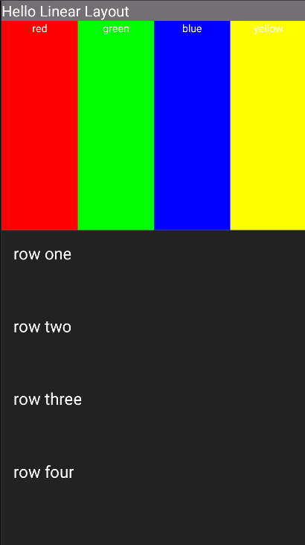

Relative Layout:

MainActivity.java:
package com.example.demo;

import android.os.Bundle;
import androidx.appcompat.app.AppCompatActivity;

public class MainActivity extends AppCompatActivity {

@Override
protected void onCreate(Bundle savedInstanceState) {
super.onCreate(savedInstanceState);
setContentView(R.layout.activity_main);
}
}

activity_main.xml:
<?xml version="1.0" encoding="utf-8"?>
<RelativeLayout xmlns:android="http://schemas.android.com/apk/res/android"
android:layout_width="match_parent"
android:layout_height="match_parent"
android:background="#111111"
>

<TextView
android:layout_width="match_parent"
android:layout_height="wrap_content"
android:text="Hello Relative Layout"
android:background="#69767474"
android:textColor="@color/white"
/>

<TextView
android:id="@+id/label"
android:layout_width="wrap_content"
android:layout_height="wrap_content"
android:text="Type here:"
android:textColor="#FFFFFF"
android:paddingLeft="16dp"
android:layout_marginTop="25dp"/>

<EditText
android:id="@+id/inputBox"
android:layout_width="match_parent"
android:layout_height="wrap_content"
android:layout_below="@id/label"
android:layout_marginTop="8dp"

android:background="@drawable/input_border"/>

<Button
android:id="@+id/cancelBtn"
android:layout_width="wrap_content"
android:layout_height="wrap_content"
android:layout_below="@id/inputBox"
android:layout_alignParentEnd="true"
android:layout_marginTop="14dp"
android:layout_marginEnd="121dp"
android:background="@drawable/flat_button"
android:text="Cancel"
android:textColor="@color/black" />

<Button
android:id="@+id/okBtn"
android:layout_width="wrap_content"
android:layout_height="wrap_content"
android:text="OK"
android:background="@drawable/flat_button"
android:textColor="@color/black"
android:layout_below="@id/inputBox"
android:layout_alignParentEnd="true"
android:layout_marginTop="12dp"
/>

</RelativeLayout>

input_border.xml:
<?xml version="1.0" encoding="utf-8"?>
<shape xmlns:android="http://schemas.android.com/apk/res/android">
<solid android:color="#FFFFFF"/>
<corners android:radius="8dp"/>
<stroke android:width="2dp" android:color="#FFD700"/>
<padding android:left="8dp" android:right="8dp" android:top="8dp" android:bottom="8dp"/>
</shape>

flat_button.xml:
<?xml version="1.0" encoding="utf-8"?>
<shape xmlns:android="http://schemas.android.com/apk/res/android">
<solid android:color="#E0E0E0"/>
<stroke android:width="1dp" android:color="#888888"/>
<corners android:radius="0dp"/>
</shape>

UI :
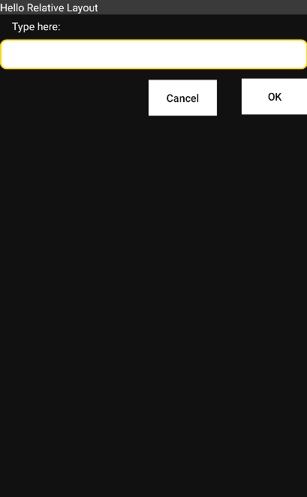

Q4: Create an app such that when the user click on the given URL typed by the user, it visits the corresponding page.

MainActivity.java:
package com.example.demo;

import android.content.Intent;
import android.net.Uri;
import android.os.Bundle;
import android.view.View;
import android.widget.EditText;
import android.widget.Toast;
import androidx.appcompat.app.AppCompatActivity;

public class MainActivity extends AppCompatActivity {

EditText urlInput;

@Override
protected void onCreate(Bundle savedInstanceState) {
super.onCreate(savedInstanceState);
setContentView(R.layout.activity_main);

urlInput = findViewById(R.id.urlInput);
}

public void openWebsite(View view) {
String url = urlInput.getText().toString().trim();

if (url.isEmpty()) {
Toast.makeText(this, "Please enter a URL", Toast.LENGTH_SHORT).show();
return;
}

if (!url.startsWith("http://") && !url.startsWith("https://")) {
url = "https://" + url;
}

Intent intent = new Intent(Intent.ACTION_VIEW, Uri.parse(url));
startActivity(intent);
}
}

activity_main.xml:
<?xml version="1.0" encoding="utf-8"?>
<LinearLayout xmlns:android="http://schemas.android.com/apk/res/android"
android:layout_width="match_parent"
android:layout_height="match_parent"
android:orientation="vertical"
android:padding="16dp">

<EditText
android:id="@+id/urlInput"
android:layout_width="match_parent"
android:layout_height="wrap_content"
android:hint="Enter URL (e.g. google.com)"
android:inputType="textUri"/>

<Button
android:layout_width="match_parent"
android:layout_height="wrap_content"
android:text="Go to Website"
android:textColor="@color/black"
android:onClick="openWebsite"/>

</LinearLayout>

UI:
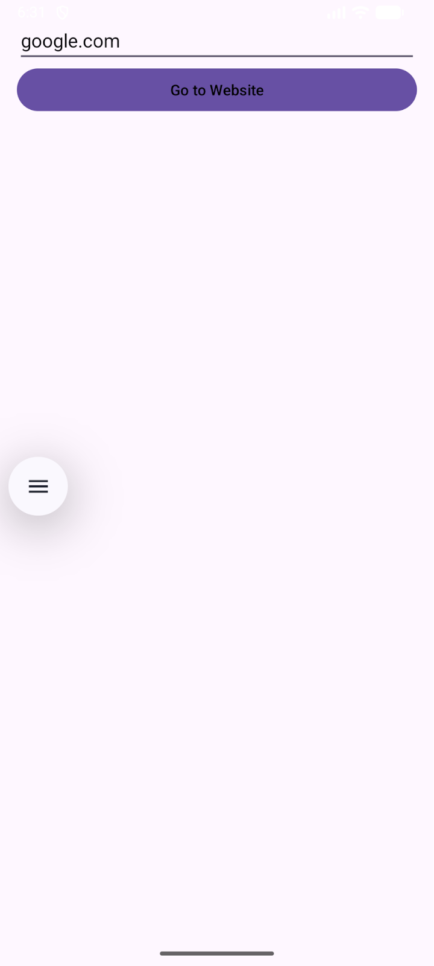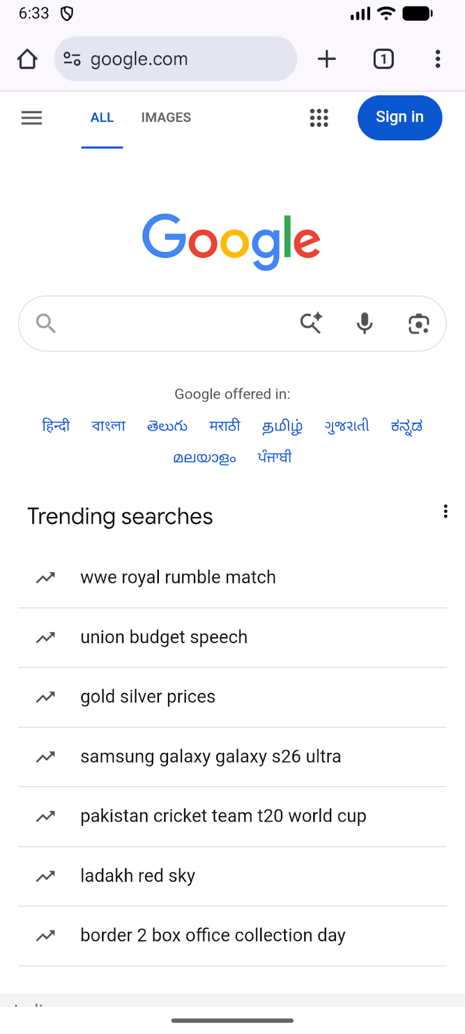

Lab 3: ACTIVITY AND LAYOUT CONTINUED

Q1: Using given scenario develop an application to perform following layout operations:
▪ List view ▪ Grid view ▪ Tab layout ▪ Table layout
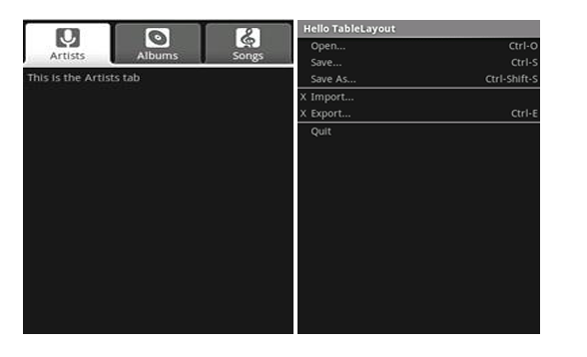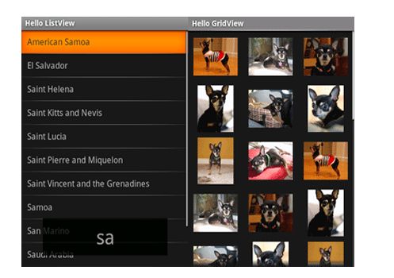
MainActivity.java:
package com.example.demo;

import android.os.Bundle;
import androidx.appcompat.app.AppCompatActivity;
import androidx.viewpager2.widget.ViewPager2;
import com.google.android.material.tabs.TabLayout;
import com.google.android.material.tabs.TabLayoutMediator;

public class MainActivity extends AppCompatActivity {

@Override
protected void onCreate(Bundle savedInstanceState) {
super.onCreate(savedInstanceState);
setContentView(R.layout.activity_main);

TabLayout tabLayout = findViewById(R.id.tabLayout);
ViewPager2 viewPager = findViewById(R.id.viewPager);

viewPager.setAdapter(new ViewPagerAdapter(this));

new TabLayoutMediator(tabLayout, viewPager, (tab, position) -> {
if (position == 0) tab.setText("Artists");
else if (position == 1) tab.setText("Albums");
else tab.setText("Songs");
}).attach();
}
}

AlbumsFragment.java:
package com.example.demo;

import android.os.Bundle;
import android.view.*;
import android.widget.GridView;
import androidx.fragment.app.Fragment;

public class AlbumsFragment extends Fragment {

int[] images = {
R.drawable.dog1, R.drawable.dog2, R.drawable.dog3,
R.drawable.dog4, R.drawable.dog5, R.drawable.dog6
};

@Override
public View onCreateView(LayoutInflater inflater, ViewGroup container, Bundle savedInstanceState) {
View v = inflater.inflate(R.layout.fragment_albums, container, false);
GridView gridView = v.findViewById(R.id.gridView);
gridView.setAdapter(new ImageAdapter(getContext(), images));
return v;
}
}

ArtistsFragment.java:
package com.example.demo;

import android.os.Bundle;
import android.view.*;
import android.widget.*;
import androidx.fragment.app.Fragment;

public class ArtistsFragment extends Fragment {

@Override
public View onCreateView(LayoutInflater inflater, ViewGroup container, Bundle savedInstanceState) {
View v = inflater.inflate(R.layout.fragment_artists, container, false);

String[] countries = {
"American Samoa","El Salvador","Saint Helena",
"Saint Kitts and Nevis","Saint Lucia","Saint Pierre and Miquelon",
"Saint Vincent and the Grenadines","Samoa","San Marino","Saudi Arabia"
};

ListView listView = v.findViewById(R.id.listView);
ArrayAdapter<String> adapter = new ArrayAdapter<>(getContext(),
R.layout.list_item_white,
R.id.itemText,
countries);

listView.setAdapter(adapter);

return v;
}
}

ImageAdapter.java:
package com.example.demo;

import android.content.Context;
import android.view.*;
import android.widget.*;

public class ImageAdapter extends BaseAdapter {

Context context;
int[] images;

public ImageAdapter(Context c, int[] imgs) {
context = c;
images = imgs;
}

public int getCount() { return images.length; }
public Object getItem(int pos) { return images[pos]; }
public long getItemId(int pos) { return pos; }

public View getView(int pos, View convertView, ViewGroup parent) {
ImageView iv = new ImageView(context);
iv.setImageResource(images[pos]);
iv.setLayoutParams(new GridView.LayoutParams(300, 300));
iv.setScaleType(ImageView.ScaleType.CENTER_CROP);
return iv;
}
}

SongsFragment.java:
package com.example.demo;

import android.os.Bundle;
import android.view.*;
import androidx.fragment.app.Fragment;

public class SongsFragment extends Fragment {
@Override
public View onCreateView(LayoutInflater inflater, ViewGroup container, Bundle savedInstanceState) {
return inflater.inflate(R.layout.fragment_songs, container, false);
}
}

ViewPagerAdapter.java:
package com.example.demo;

import androidx.annotation.NonNull;
import androidx.fragment.app.Fragment;
import androidx.fragment.app.FragmentActivity;
import androidx.viewpager2.adapter.FragmentStateAdapter;

public class ViewPagerAdapter extends FragmentStateAdapter {

public ViewPagerAdapter(@NonNull FragmentActivity fa) {
super(fa);
}

@NonNull
@Override
public Fragment createFragment(int position) {
if (position == 0) return new ArtistsFragment();
else if (position == 1) return new AlbumsFragment();
else return new SongsFragment();
}

@Override
public int getItemCount() {
return 3;
}
}

activity_main.xml:
<LinearLayout xmlns:android="http://schemas.android.com/apk/res/android"
xmlns:app="http://schemas.android.com/apk/res-auto"
android:layout_width="match_parent"
android:layout_height="match_parent"
android:orientation="vertical">

<com.google.android.material.tabs.TabLayout
android:id="@+id/tabLayout"
android:layout_width="match_parent"
android:layout_height="wrap_content"
android:background="#333333"
app:tabTextColor="@color/white"
app:tabSelectedTextColor="#FFFFFF"
app:tabIndicatorColor="#FFFFFF"/>

<androidx.viewpager2.widget.ViewPager2
android:id="@+id/viewPager"
android:layout_width="match_parent"
android:layout_height="match_parent"
/>
</LinearLayout>

fragment_albums.xml:
<GridView xmlns:android="http://schemas.android.com/apk/res/android"
android:id="@+id/gridView"
android:layout_width="match_parent"
android:layout_height="match_parent"
android:numColumns="3"
android:verticalSpacing="8dp"
android:horizontalSpacing="8dp"
android:background="#111111"
android:padding="8dp"/>

fragment_artists.xml:
<ListView xmlns:android="http://schemas.android.com/apk/res/android"
android:id="@+id/listView"
android:layout_width="match_parent"
android:layout_height="match_parent"
android:background="#111111"
android:divider="#444444"
android:dividerHeight="1dp"/>

fragment_songs.xml:
<TableLayout xmlns:android="http://schemas.android.com/apk/res/android"
android:layout_width="match_parent"
android:layout_height="match_parent"
android:background="#111111"
android:stretchColumns="*"
android:padding="10dp">

<TableRow>
<TextView android:text="Open..." android:textColor="#FFFFFF"/>
<TextView android:text="Ctrl+O" android:textColor="#AAAAAA"/>
</TableRow>

<TableRow>
<TextView android:text="Save..." android:textColor="#FFFFFF"/>
<TextView android:text="Ctrl+S" android:textColor="#AAAAAA"/>
</TableRow>

<TableRow>
<TextView android:text="Import..." android:textColor="#FFFFFF"/>
<TextView android:text="Ctrl+I" android:textColor="#AAAAAA"/>
</TableRow>

<TableRow>
<TextView android:text="Export..." android:textColor="#FFFFFF"/>
<TextView android:text="Ctrl+E" android:textColor="#AAAAAA"/>
</TableRow>

<TableRow>
<TextView android:text="Quit" android:textColor="#FFFFFF"/>
<TextView android:text="Ctrl+Q" android:textColor="#AAAAAA"/>
</TableRow>
</TableLayout>

list_item_white.xml:
<?xml version="1.0" encoding="utf-8"?>
<TextView xmlns:android="http://schemas.android.com/apk/res/android"
android:id="@+id/itemText"
android:layout_width="match_parent"
android:layout_height="wrap_content"
android:textColor="#FFFFFF"
android:textSize="16sp"
android:padding="12dp"
android:background="#111111"/>

UI:
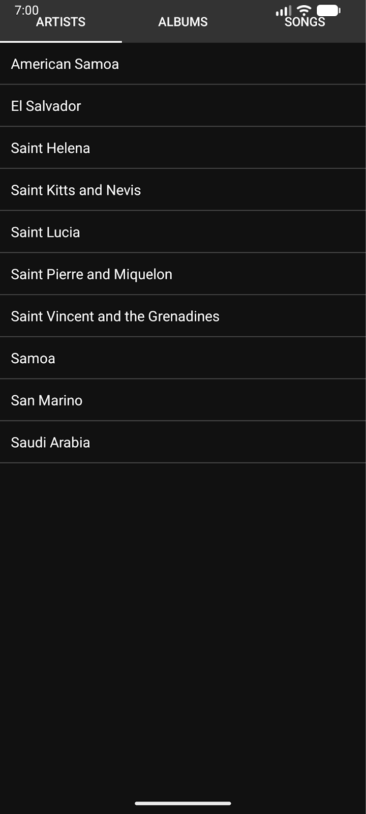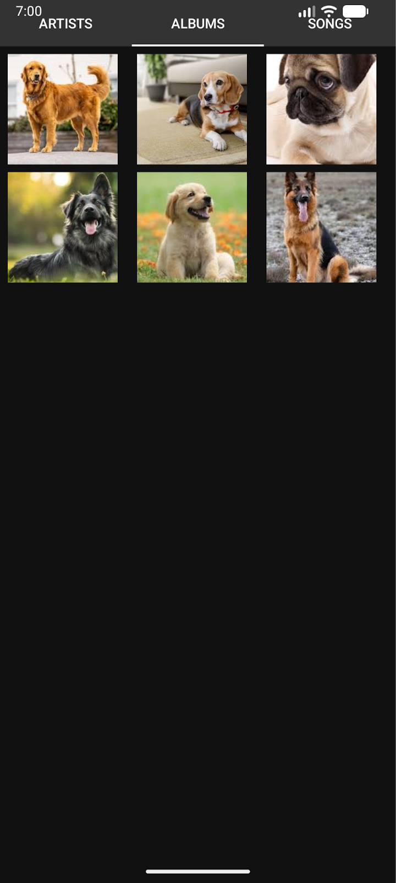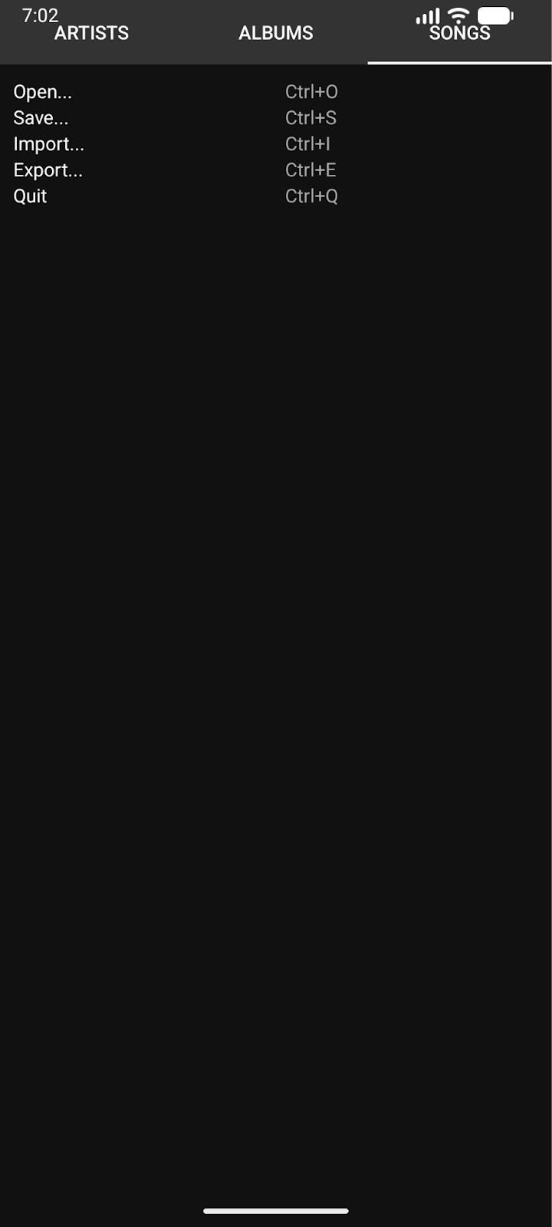

Q2: Write a program to list different sports, and when a sport is selected, display a message showing the selected sport.

MainActivity.java:
package com.example.demo;

import android.os.Bundle;
import android.view.View;
import android.widget.ArrayAdapter;
import android.widget.ListView;
import android.widget.Toast;

import androidx.appcompat.app.AppCompatActivity;

public class MainActivity extends AppCompatActivity {

ListView sportsListView;

@Override
protected void onCreate(Bundle savedInstanceState) {
super.onCreate(savedInstanceState);
setContentView(R.layout.activity_main);

sportsListView = findViewById(R.id.sportsListView);

String[] sports = {
"Cricket",
"Football",
"Tennis",
"Basketball",
"Hockey",
"Badminton",
"Volleyball"
};

ArrayAdapter<String> adapter = new ArrayAdapter<>(
this,
android.R.layout.simple_list_item_1,
sports
);

sportsListView.setAdapter(adapter);

sportsListView.setOnItemClickListener((parent, view, position, id) -> {
String selectedSport = sports[position];
Toast.makeText(MainActivity.this,
"Selected Sport: " + selectedSport,
Toast.LENGTH_SHORT).show();
});
}
}

activity_main.xml:
<?xml version="1.0" encoding="utf-8"?>
<ListView xmlns:android="http://schemas.android.com/apk/res/android"
android:id="@+id/sportsListView"
android:layout_width="match_parent"
android:layout_height="match_parent" />

UI:

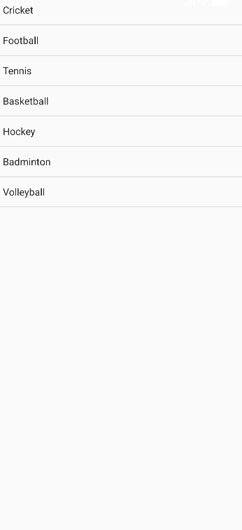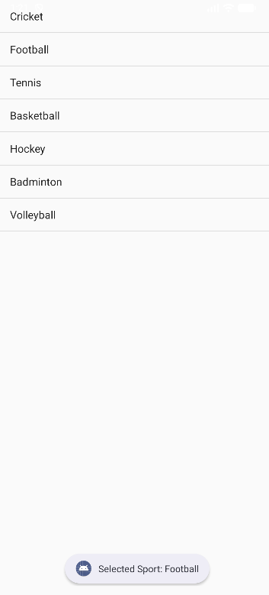

Q3: Design an news application and Implement the navigation between sections like Top Stories, Sports, and Entertainment using tab layout.

MainActivity.java:
package com.example.demo;

import android.os.Bundle;
import androidx.appcompat.app.AppCompatActivity;
import androidx.viewpager.widget.ViewPager;
import com.google.android.material.tabs.TabLayout;

public class MainActivity extends AppCompatActivity {

@Override
protected void onCreate(Bundle savedInstanceState) {
super.onCreate(savedInstanceState);
setContentView(R.layout.activity_main);

TabLayout tabLayout = findViewById(R.id.tabLayout);
ViewPager viewPager = findViewById(R.id.viewPager);

ViewPagerAdapter adapter = new ViewPagerAdapter(getSupportFragmentManager());
adapter.addFragment(new TopStoriesFragment(), "Top Stories");
adapter.addFragment(new SportsFragment(), "Sports");
adapter.addFragment(new EntertainmentFragment(), "Entertainment");

viewPager.setAdapter(adapter);
tabLayout.setupWithViewPager(viewPager);
}
}

EntertainmentFragment.java:
package com.example.demo;

import android.os.Bundle;
import android.view.LayoutInflater;
import android.view.View;
import android.view.ViewGroup;
import android.widget.ArrayAdapter;
import android.widget.ListView;

import androidx.fragment.app.Fragment;

public class EntertainmentFragment extends Fragment {

@Override
public View onCreateView(LayoutInflater inflater, ViewGroup container, Bundle savedInstanceState) {
View v = inflater.inflate(R.layout.fragment_list, container, false);
ListView listView = v.findViewById(R.id.listView);

String[] entertainmentNews = {
"New Movie Releases",
"Celebrity Interviews",
"Music Festival Updates",
"Award Show Highlights"
};

ArrayAdapter<String> adapter = new ArrayAdapter<>(getContext(),
android.R.layout.simple_list_item_1, entertainmentNews);

listView.setAdapter(adapter);
return v;
}
}

SportsFragment.java:
package com.example.demo;

import android.os.Bundle;
import android.view.LayoutInflater;
import android.view.View;
import android.view.ViewGroup;
import android.widget.ArrayAdapter;
import android.widget.ListView;

import androidx.fragment.app.Fragment;

public class SportsFragment extends Fragment {

@Override
public View onCreateView(LayoutInflater inflater, ViewGroup container, Bundle savedInstanceState) {
View v = inflater.inflate(R.layout.fragment_list, container, false);
ListView listView = v.findViewById(R.id.listView);

String[] sportsNews = {
"Football World Cup Updates",
"Cricket Series Highlights",
"Olympics Preparation",
"Tennis Grand Slam News"
};

ArrayAdapter<String> adapter = new ArrayAdapter<>(getContext(),
android.R.layout.simple_list_item_1, sportsNews);

listView.setAdapter(adapter);
return v;
}
}

TopStoriesFragment.java:
package com.example.demo;

import android.os.Bundle;
import android.view.LayoutInflater;
import android.view.View;
import android.view.ViewGroup;
import android.widget.ArrayAdapter;
import android.widget.ListView;

import androidx.fragment.app.Fragment;

public class TopStoriesFragment extends Fragment {

@Override
public View onCreateView(LayoutInflater inflater, ViewGroup container, Bundle savedInstanceState) {
View v = inflater.inflate(R.layout.fragment_list, container, false);
ListView listView = v.findViewById(R.id.listView);

String[] news = {
"Global Market Updates",
"New Technology Trends",
"Political Developments",
"Climate Change News"
};

ArrayAdapter<String> adapter = new ArrayAdapter<>(getContext(),
android.R.layout.simple_list_item_1, news);

listView.setAdapter(adapter);
return v;
}
}

ViewPagerAdapter.java:
package com.example.demo;

import androidx.annotation.NonNull;
import androidx.fragment.app.Fragment;
import androidx.fragment.app.FragmentManager;
import androidx.fragment.app.FragmentPagerAdapter;
import java.util.ArrayList;
import java.util.List;

public class ViewPagerAdapter extends FragmentPagerAdapter {

private final List<Fragment> fragmentList = new ArrayList<>();
private final List<String> fragmentTitleList = new ArrayList<>();

public ViewPagerAdapter(FragmentManager manager) {
super(manager);
}

@NonNull
@Override
public Fragment getItem(int position) {
return fragmentList.get(position);
}

@Override
public int getCount() {
return fragmentList.size();
}

public void addFragment(Fragment fragment, String title) {
fragmentList.add(fragment);
fragmentTitleList.add(title);
}

@Override
public CharSequence getPageTitle(int position) {
return fragmentTitleList.get(position);
}
}

activity_main.xml:
<?xml version="1.0" encoding="utf-8"?>
<LinearLayout xmlns:android="http://schemas.android.com/apk/res/android"
xmlns:app="http://schemas.android.com/apk/res-auto"
android:layout_width="match_parent"
android:layout_height="match_parent"
android:orientation="vertical">

<com.google.android.material.tabs.TabLayout
android:id="@+id/tabLayout"
android:layout_width="match_parent"
android:layout_height="wrap_content" />

<androidx.viewpager.widget.ViewPager
android:id="@+id/viewPager"
android:layout_width="match_parent"
android:layout_height="match_parent"/>

</LinearLayout>

fragment_list.xml:
<ListView xmlns:android="http://schemas.android.com/apk/res/android"
android:id="@+id/listView"
android:layout_width="match_parent"
android:layout_height="match_parent"/>

UI:
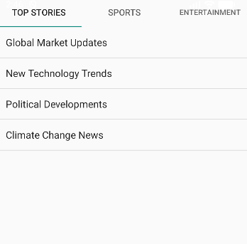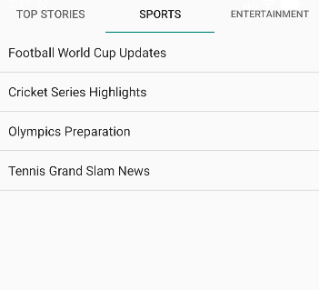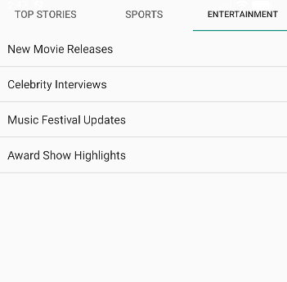
Lab 4: INPUT CONTROLS IN ANDROID

Q1: Develop a "Test App" that includes a layout with a Button and a ToggleButton. When each button is clicked, a custom Toast message should be displayed with different images as their content.

MainActivity.java:
package com.example.demo;

import android.os.Bundle;
import android.view.LayoutInflater;
import android.view.View;
import android.widget.Button;
import android.widget.ImageView;
import android.widget.TextView;
import android.widget.Toast;
import android.widget.ToggleButton;

import androidx.appcompat.app.AppCompatActivity;

public class MainActivity extends AppCompatActivity {

Button btnShow;
ToggleButton toggleShow;

@Override
protected void onCreate(Bundle savedInstanceState) {
super.onCreate(savedInstanceState);
setContentView(R.layout.activity_main);

btnShow = findViewById(R.id.btnShow);
toggleShow = findViewById(R.id.toggleShow);

btnShow.setOnClickListener(v -> showCustomToast("Button Clicked!", R.drawable.button_image));

toggleShow.setOnCheckedChangeListener((buttonView, isChecked) -> {
if (isChecked) {
showCustomToast("Toggle ON", R.drawable.toggle_on);
} else {
showCustomToast("Toggle OFF", R.drawable.toggle_off);
}
});
}

private void showCustomToast(String message, int imageRes) {
LayoutInflater inflater = getLayoutInflater();
View layout = inflater.inflate(R.layout.custom_toast, null);

ImageView image = layout.findViewById(R.id.toastImage);
TextView text = layout.findViewById(R.id.toastText);

image.setImageResource(imageRes);
text.setText(message);

Toast toast = new Toast(getApplicationContext());
toast.setDuration(Toast.LENGTH_SHORT);
toast.setView(layout);
toast.show();
}
}

activity_main.xml:
<?xml version="1.0" encoding="utf-8"?>
<LinearLayout xmlns:android="http://schemas.android.com/apk/res/android"
android:layout_width="match_parent"
android:layout_height="match_parent"
android:gravity="center"
android:orientation="vertical"
android:padding="20dp">

<Button
android:id="@+id/btnShow"
android:layout_width="wrap_content"
android:layout_height="wrap_content"
android:text="Show Toast" />

<ToggleButton
android:id="@+id/toggleShow"
android:layout_width="wrap_content"
android:layout_height="wrap_content"
android:textOn="Toast ON"
android:textOff="Toast OFF"
android:layout_marginTop="20dp" />

</LinearLayout>

custom_toast.xml:
<?xml version="1.0" encoding="utf-8"?>
<LinearLayout xmlns:android="http://schemas.android.com/apk/res/android"
android:layout_width="wrap_content"
android:layout_height="wrap_content"
android:orientation="vertical"
android:padding="10dp"
android:background="#DD000000"
android:gravity="center">

<ImageView
android:id="@+id/toastImage"
android:layout_width="80dp"
android:layout_height="80dp"
android:src="@drawable/ic_launcher_foreground" />

<TextView
android:id="@+id/toastText"
android:layout_width="wrap_content"
android:layout_height="wrap_content"
android:textColor="#FFFFFF"
android:textSize="16sp"
android:paddingTop="5dp"/>
</LinearLayout>

UI:
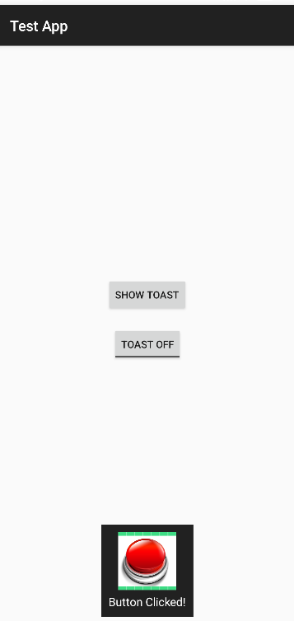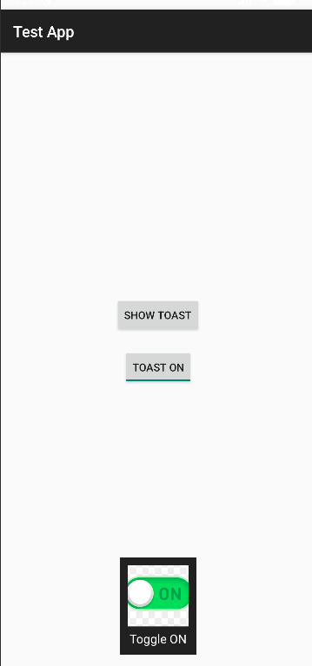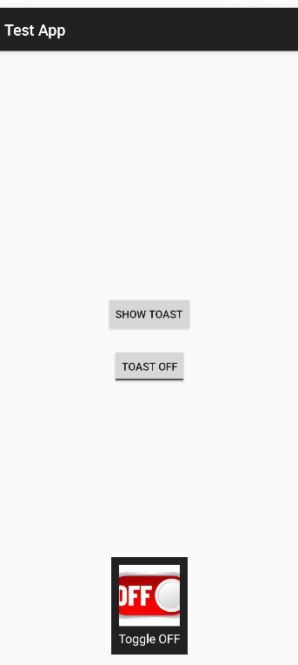

Q2: Create an app that contains a view with multiple buttons, each labeled with different Android versions. When a button is clicked, a Toast message should appear, displaying the corresponding Android version's name along with its associated icon.

MainActivity.java:
package com.example.demo;

import android.os.Bundle;
import android.view.LayoutInflater;
import android.view.View;
import android.widget.Button;
import android.widget.ImageView;
import android.widget.TextView;
import android.widget.Toast;

import androidx.appcompat.app.AppCompatActivity;

public class MainActivity extends AppCompatActivity {

@Override
protected void onCreate(Bundle savedInstanceState) {
super.onCreate(savedInstanceState);
setContentView(R.layout.activity_main);

findViewById(R.id.btnCupcake).setOnClickListener(v ->
showToast("Android Cupcake", R.drawable.cupcake));

findViewById(R.id.btnKitKat).setOnClickListener(v ->
showToast("Android KitKat", R.drawable.kitkat));

findViewById(R.id.btnLollipop).setOnClickListener(v ->
showToast("Android Lollipop", R.drawable.lollipop));

findViewById(R.id.btnPie).setOnClickListener(v ->
showToast("Android Pie", R.drawable.pie));
}

private void showToast(String message, int imageRes) {
LayoutInflater inflater = getLayoutInflater();
View layout = inflater.inflate(R.layout.custom_toast, null);

ImageView image = layout.findViewById(R.id.toastImage);
TextView text = layout.findViewById(R.id.toastText);

image.setImageResource(imageRes);
text.setText(message);

Toast toast = new Toast(getApplicationContext());
toast.setDuration(Toast.LENGTH_SHORT);
toast.setView(layout);
toast.show();
}
}

activity_main.xml:
<?xml version="1.0" encoding="utf-8"?>
<ScrollView xmlns:android="http://schemas.android.com/apk/res/android"
android:layout_width="match_parent"
android:layout_height="match_parent">

<LinearLayout
android:layout_width="match_parent"
android:layout_height="wrap_content"
android:orientation="vertical"
android:gravity="center"
android:padding="20dp">

<Button
android:id="@+id/btnCupcake"
android:layout_width="match_parent"
android:layout_height="wrap_content"
android:text="Android 1.5 - Cupcake"/>

<Button
android:id="@+id/btnKitKat"
android:layout_width="match_parent"
android:layout_height="wrap_content"
android:text="Android 4.4 - KitKat"
android:layout_marginTop="10dp"/>

<Button
android:id="@+id/btnLollipop"
android:layout_width="match_parent"
android:layout_height="wrap_content"
android:text="Android 5.0 - Lollipop"
android:layout_marginTop="10dp"/>

<Button
android:id="@+id/btnPie"
android:layout_width="match_parent"
android:layout_height="wrap_content"
android:text="Android 9 - Pie"
android:layout_marginTop="10dp"/>

</LinearLayout>
</ScrollView>

custom_toast.xml:
<?xml version="1.0" encoding="utf-8"?>
<LinearLayout xmlns:android="http://schemas.android.com/apk/res/android"
android:layout_width="wrap_content"
android:layout_height="wrap_content"
android:orientation="horizontal"
android:padding="10dp"
android:background="#DD000000"
android:gravity="center_vertical">

<ImageView
android:id="@+id/toastImage"
android:layout_width="50dp"
android:layout_height="50dp"
android:layout_marginEnd="10dp"/>

<TextView
android:id="@+id/toastText"
android:layout_width="wrap_content"
android:layout_height="wrap_content"
android:textColor="#FFFFFF"
android:textSize="16sp"/>
</LinearLayout>

UI:
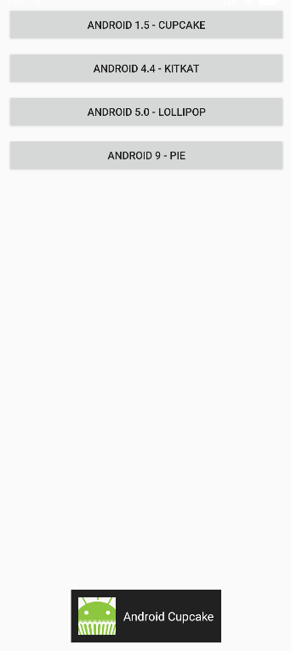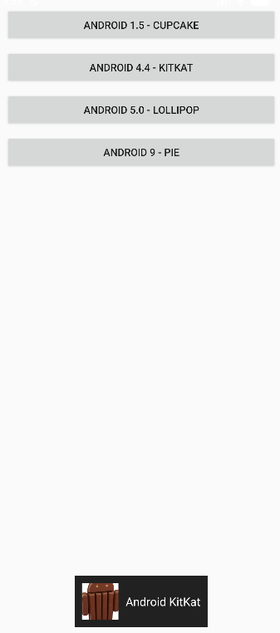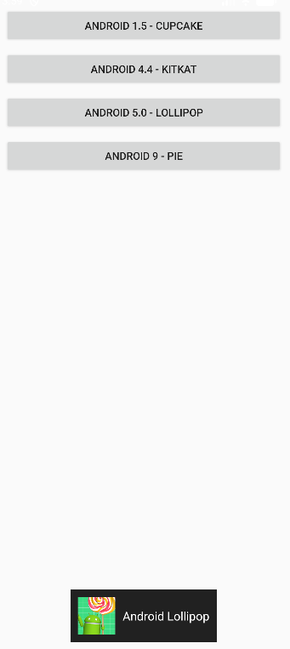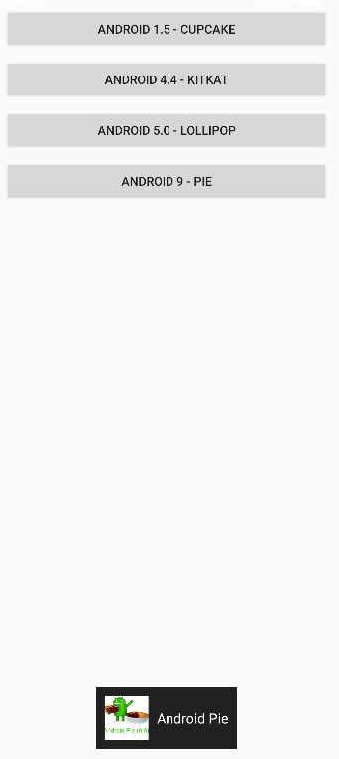

Q3: Develop a view with a ToggleButton labeled "Current Mode" that has two states: "Wi-Fi" and "Mobile Data." Based on the state of the toggle button, an image corresponding to the selected mode should appear, and a Toast message should display the current mode. Additionally, when the user clicks the "Change Mode" button, the app should switch to the corresponding mode and update the image accordingly.

MainActivity.java:
package com.example.demo;

import android.os.Bundle;
import android.widget.Button;
import android.widget.ImageView;
import android.widget.Toast;
import android.widget.ToggleButton;

import androidx.appcompat.app.AppCompatActivity;

public class MainActivity extends AppCompatActivity {

ToggleButton toggleMode;
ImageView modeImage;
Button btnChange;

@Override
protected void onCreate(Bundle savedInstanceState) {
super.onCreate(savedInstanceState);
setContentView(R.layout.activity_main);

toggleMode = findViewById(R.id.toggleMode);
modeImage = findViewById(R.id.modeImage);
btnChange = findViewById(R.id.btnChange);

toggleMode.setOnCheckedChangeListener((buttonView, isChecked) -> {
if (isChecked) {
modeImage.setImageResource(R.drawable.wifi);
Toast.makeText(this, "Current Mode: Wi-Fi", Toast.LENGTH_SHORT).show();
} else {
modeImage.setImageResource(R.drawable.mobile_data);
Toast.makeText(this, "Current Mode: Mobile Data", Toast.LENGTH_SHORT).show();
}
});

btnChange.setOnClickListener(v -> {
toggleMode.toggle();
});
}
}

activity_main.xml:
<?xml version="1.0" encoding="utf-8"?>
<LinearLayout xmlns:android="http://schemas.android.com/apk/res/android"
android:layout_width="match_parent"
android:layout_height="match_parent"
android:orientation="vertical"
android:gravity="center"
android:padding="24dp">

<ToggleButton
android:id="@+id/toggleMode"
android:layout_width="wrap_content"
android:layout_height="wrap_content"
android:textOn="Wi-Fi"
android:textOff="Mobile Data"
android:text="Current Mode" />

<ImageView
android:id="@+id/modeImage"
android:layout_width="150dp"
android:layout_height="150dp"
android:layout_marginTop="24dp"
android:src="@drawable/mobile_data" />

<Button
android:id="@+id/btnChange"
android:layout_width="wrap_content"
android:layout_height="wrap_content"
android:text="Change Mode"
android:layout_marginTop="24dp"/>

</LinearLayout>

UI:
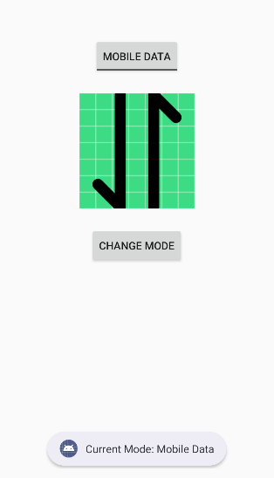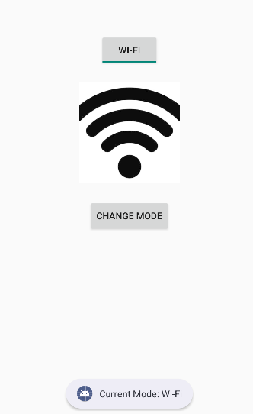

Q4: Create a “Food Ordering App” which lists food items with check boxes. Once the user checks /unchecks the item and click on the submit button display the items ordered along with cost of each item and total cost in a new activity. Once the user clicks on the submit button he/she should not be allowed to change the order i.e. he should not be allowed to change the state of the items checked.

MainActivity.java:
package com.example.demo;

import android.content.Intent;
import android.os.Bundle;
import android.widget.Button;
import android.widget.CheckBox;

import androidx.appcompat.app.AppCompatActivity;

public class MainActivity extends AppCompatActivity {

CheckBox cbBurger, cbPizza, cbPasta, cbSandwich, cbCoffee;
Button btnSubmit;

@Override
protected void onCreate(Bundle savedInstanceState) {
super.onCreate(savedInstanceState);
setContentView(R.layout.activity_main);

cbBurger = findViewById(R.id.cbBurger);
cbPizza = findViewById(R.id.cbPizza);
cbPasta = findViewById(R.id.cbPasta);
cbSandwich = findViewById(R.id.cbSandwich);
cbCoffee = findViewById(R.id.cbCoffee);
btnSubmit = findViewById(R.id.btnSubmit);

btnSubmit.setOnClickListener(v -> {

StringBuilder orderDetails = new StringBuilder();
int total = 0;

if (cbBurger.isChecked()) {
orderDetails.append("Burger - ₹120\n");
total += 120;
}
if (cbPizza.isChecked()) {
orderDetails.append("Pizza - ₹250\n");
total += 250;
}
if (cbPasta.isChecked()) {
orderDetails.append("Pasta - ₹180\n");
total += 180;
}
if (cbSandwich.isChecked()) {
orderDetails.append("Sandwich - ₹100\n");
total += 100;
}
if (cbCoffee.isChecked()) {
orderDetails.append("Coffee - ₹80\n");
total += 80;
}

Intent intent = new Intent(MainActivity.this, ResultActivity.class);
intent.putExtra("order", orderDetails.toString());
intent.putExtra("total", total);
startActivity(intent);

cbBurger.setEnabled(false);
cbPizza.setEnabled(false);
cbPasta.setEnabled(false);
cbSandwich.setEnabled(false);
cbCoffee.setEnabled(false);
btnSubmit.setEnabled(false);
});
}
}

activity_main.xml:
<?xml version="1.0" encoding="utf-8"?>
<ScrollView xmlns:android="http://schemas.android.com/apk/res/android"
android:layout_width="match_parent"
android:layout_height="match_parent">

<LinearLayout
android:layout_width="match_parent"
android:layout_height="wrap_content"
android:orientation="vertical"
android:padding="20dp">

<TextView
android:text="Select Your Food"
android:textSize="22sp"
android:textStyle="bold"
android:paddingBottom="16dp" android:layout_height="wrap_content" android:layout_width="wrap_content"/>

<CheckBox
android:id="@+id/cbBurger"
android:text="Burger - ₹120" android:layout_height="wrap_content" android:layout_width="wrap_content"/>

<CheckBox
android:id="@+id/cbPizza"
android:text="Pizza - ₹250" android:layout_height="wrap_content" android:layout_width="wrap_content"/>

<CheckBox
android:id="@+id/cbPasta"
android:text="Pasta - ₹180" android:layout_height="wrap_content" android:layout_width="wrap_content"/>

<CheckBox
android:id="@+id/cbSandwich"
android:text="Sandwich - ₹100" android:layout_height="wrap_content" android:layout_width="wrap_content"/>

<CheckBox
android:id="@+id/cbCoffee"
android:text="Coffee - ₹80" android:layout_height="wrap_content" android:layout_width="wrap_content"/>

<Button
android:id="@+id/btnSubmit"
android:layout_width="match_parent"
android:layout_height="wrap_content"
android:text="Submit Order"
android:layout_marginTop="20dp"/>

</LinearLayout>
</ScrollView>

ResultAcitivity.java:
package com.example.demo;

import android.os.Bundle;
import android.widget.TextView;

import androidx.appcompat.app.AppCompatActivity;

public class ResultActivity extends AppCompatActivity {

TextView tvOrder, tvTotal;

@Override
protected void onCreate(Bundle savedInstanceState) {
super.onCreate(savedInstanceState);
setContentView(R.layout.activity_result);

tvOrder = findViewById(R.id.tvOrder);
tvTotal = findViewById(R.id.tvTotal);

String order = getIntent().getStringExtra("order");
int total = getIntent().getIntExtra("total", 0);

tvOrder.setText(order);
tvTotal.setText("Total Cost: ₹" + total);
}
}

activity_result.xml:
<?xml version="1.0" encoding="utf-8"?>
<LinearLayout xmlns:android="http://schemas.android.com/apk/res/android"
android:layout_width="match_parent"
android:layout_height="match_parent"
android:orientation="vertical"
android:padding="20dp">

<TextView
android:text="Your Order"
android:textSize="22sp"
android:textStyle="bold"
android:paddingBottom="16dp" android:layout_height="wrap_content" android:layout_width="wrap_content"/>

<TextView
android:id="@+id/tvOrder"
android:textSize="18sp" android:layout_height="wrap_content" android:layout_width="wrap_content"/>

<TextView
android:id="@+id/tvTotal"
android:textSize="20sp"
android:textStyle="bold"
android:layout_marginTop="20dp" android:layout_height="wrap_content" android:layout_width="wrap_content"/>

</LinearLayout>

UI:
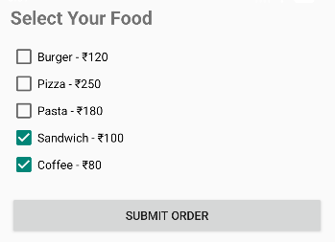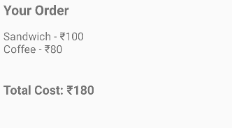

Lab 5: INPUT CONTROLS-SPINNERS, PICKERS

Q1. Develop an application named "Vehicle Parking Registration" where the user can register their vehicle for parking. The app should include a spinner that allows users to select the type of vehicle (e.g., car, bike, etc.) and text fields for entering the vehicle number and RC number. Upon clicking the submit button, the entered details should be displayed in a separate view, providing the user with options to either confirm the details or edit them. Once the user confirms the information, a toast message should appear showing a unique serial number to confirm the parking allotment.

AndroidManifest.xml
<?xml version="1.0" encoding="utf-8"?>
<manifest xmlns:android="http://schemas.android.com/apk/res/android"
xmlns:tools="http://schemas.android.com/tools">

<application
android:allowBackup="true"
android:dataExtractionRules="@xml/data_extraction_rules"
android:fullBackupContent="@xml/backup_rules"
android:icon="@mipmap/ic_launcher"
android:label="Vehicle Parking"
android:roundIcon="@mipmap/ic_launcher_round"
android:supportsRtl="true"
android:theme="@style/Theme.AppCompat.DayNight">
<activity android:name=".ConfirmationActivity"/>
<activity
android:name=".MainActivity"
android:exported="true">
<intent-filter>
<action android:name="android.intent.action.MAIN" />

<category android:name="android.intent.category.LAUNCHER" />
</intent-filter>
</activity>
</application>

</manifest>

ConfirmationActivity.java
package com.example.lab5_q1;

import android.os.Bundle;
import android.widget.Button;
import android.widget.TextView;
import android.widget.Toast;

import androidx.appcompat.app.AppCompatActivity;

import java.util.Random;

public class ConfirmationActivity extends AppCompatActivity {
TextView vehicleDetails;
Button Submit,edit;
public void onCreate(Bundle savedInstanceState) {
super.onCreate(savedInstanceState);
setContentView(R.layout.activity_confirm);
vehicleDetails=findViewById(R.id.VehicleDetails);
Submit=findViewById(R.id.buttonConfirm);
edit=findViewById(R.id.editText);
String VehicleNo=getIntent().getStringExtra("VehicleNo");
String RC=getIntent().getStringExtra("RC");
String VehicleType=getIntent().getStringExtra("VehicleType");
vehicleDetails.setText("Vehicle No: "+VehicleNo+"\n"+"RC: "+RC+"\n"+"Vehicle Type: "+VehicleType);
Submit.setOnClickListener(v->{
int serial=new Random().nextInt(1000)+1;
Toast.makeText(this, "Parking done with serial no:"+serial, Toast.LENGTH_SHORT).show();
});
edit.setOnClickListener(v->finish());
}
}

MainActivity.java

package com.example.lab5_q1;

import android.content.Intent;
import android.os.Bundle;
import android.widget.ArrayAdapter;
import android.widget.Button;
import android.widget.EditText;
import android.widget.Spinner;

import androidx.activity.EdgeToEdge;
import androidx.appcompat.app.AppCompatActivity;
import androidx.core.graphics.Insets;
import androidx.core.view.ViewCompat;
import androidx.core.view.WindowInsetsCompat;

public class MainActivity extends AppCompatActivity {
Spinner spinnerVehicle;
EditText vehicleNo;
EditText rc;
Button buttonSubmit;

@Override
protected void onCreate(Bundle savedInstanceState) {
super.onCreate(savedInstanceState);
EdgeToEdge.enable(this);
setContentView(R.layout.activity_main);
spinnerVehicle = findViewById(R.id.spinnervehicle);
vehicleNo = findViewById(R.id.vehicleNo);
rc = findViewById(R.id.rc);
buttonSubmit = findViewById(R.id.buttonSubmit);
String[] vehicles={"car","bike","truck"};
ArrayAdapter<String> adapter = new ArrayAdapter<>(
this,
android.R.layout.simple_spinner_dropdown_item,
vehicles
);
spinnerVehicle.setAdapter(adapter);
buttonSubmit.setOnClickListener(v->{
String VehicleNo=vehicleNo.getText().toString();
String RC=rc.getText().toString();
String VehicleType=spinnerVehicle.getSelectedItem().toString();
Intent intent= new Intent(MainActivity.this, ConfirmationActivity.class);
intent.putExtra("VehicleNo",VehicleNo);
intent.putExtra("RC",RC);
intent.putExtra("VehicleType",VehicleType);
startActivity(intent);
});

}
}

activity_confirm.xml
<LinearLayout xmlns:android="http://schemas.android.com/apk/res/android"
android:layout_width="match_parent"
android:layout_height="match_parent"
android:orientation="vertical">
<TextView
android:layout_width="160dp"
android:layout_height="wrap_content"

android:id="@+id/VehicleDetails"/>
<Button
android:layout_width="wrap_content"
android:layout_height="wrap_content"
android:text="Confirm"
android:id="@+id/buttonConfirm"/>
<Button
android:layout_width="wrap_content"
android:layout_height="wrap_content"
android:id="@+id/editText"
android:hint="edit"/>

</LinearLayout>

activity_main.xml

<?xml version="1.0" encoding="utf-8"?>
<androidx.constraintlayout.widget.ConstraintLayout xmlns:android="http://schemas.android.com/apk/res/android"
xmlns:app="http://schemas.android.com/apk/res-auto"
xmlns:tools="http://schemas.android.com/tools"
android:id="@+id/main"
android:layout_width="match_parent"
android:layout_height="match_parent"
android:padding="16dp"
tools:context=".MainActivity">

<TextView
android:id="@+id/TitleText"
android:layout_width="wrap_content"
android:layout_height="wrap_content"
android:text="Vehicle Parking Registration"
android:textSize="20sp"
android:textStyle="bold"
android:layout_marginTop="24dp"
app:layout_constraintEnd_toEndOf="parent"
app:layout_constraintStart_toStartOf="parent"
app:layout_constraintTop_toTopOf="parent" />

<Spinner
android:id="@+id/spinnervehicle"
android:layout_width="0dp"
android:layout_height="wrap_content"
android:layout_marginTop="20dp"
app:layout_constraintTop_toBottomOf="@+id/TitleText"
app:layout_constraintEnd_toEndOf="parent"
app:layout_constraintStart_toStartOf="parent" />

<EditText
android:id="@+id/vehicleNo"
android:layout_width="0dp"
android:layout_height="wrap_content"
android:hint="Enter vehicle number"
android:layout_marginTop="12dp"
app:layout_constraintTop_toBottomOf="@+id/spinnervehicle"
app:layout_constraintEnd_toEndOf="parent"
app:layout_constraintStart_toStartOf="parent" />

<EditText
android:id="@+id/rc"
android:layout_width="0dp"
android:layout_height="wrap_content"
android:hint="Enter RC"
android:layout_marginTop="12dp"
app:layout_constraintTop_toBottomOf="@+id/vehicleNo"
app:layout_constraintEnd_toEndOf="parent"
app:layout_constraintStart_toStartOf="parent"/>

<Button
android:id="@+id/buttonSubmit"
android:layout_width="0dp"
android:layout_height="wrap_content"
android:text="Submit"
android:layout_marginTop="24dp"
app:layout_constraintTop_toBottomOf="@+id/rc"
app:layout_constraintEnd_toEndOf="parent"
app:layout_constraintStart_toStartOf="parent"/>

</androidx.constraintlayout.widget.ConstraintLayout>

UI:
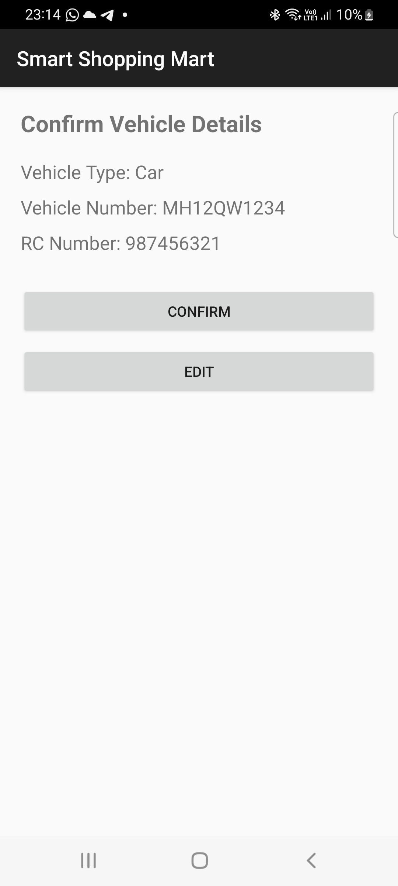
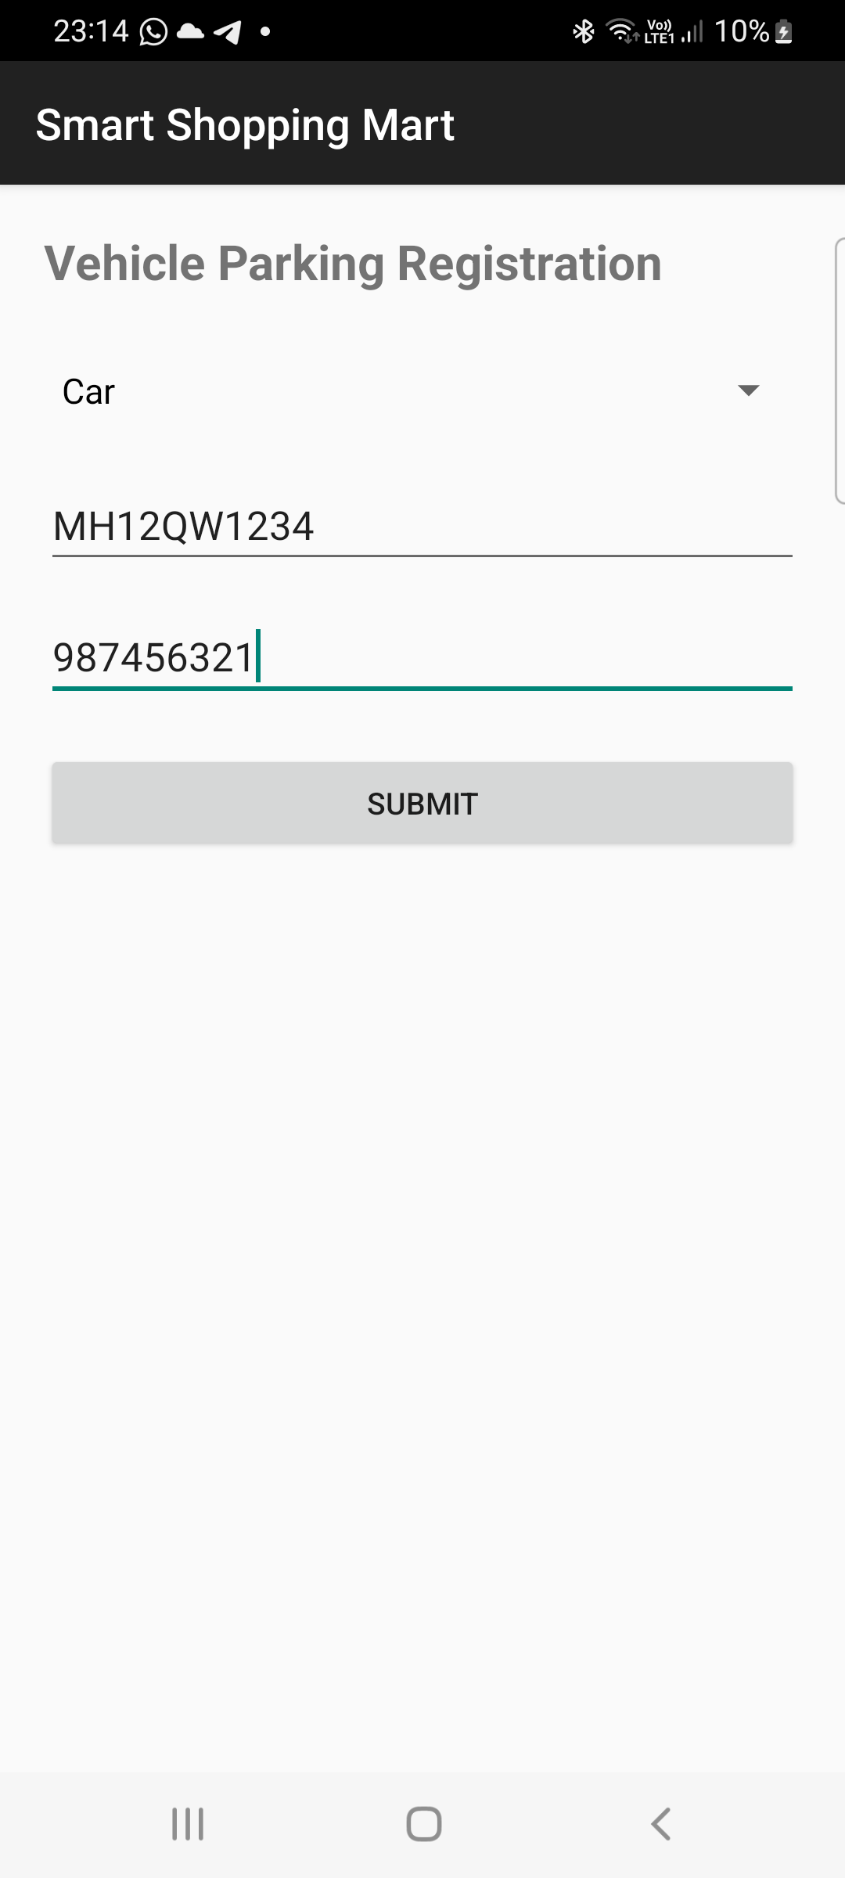

Q2. Design and develop a "Travel Ticket Booking" app where users can book tickets by selecting the source and destination from dropdown lists (spinners) and choosing the date of travel using a date picker. Include a toggle button to let users specify whether they want a one-way ticket or a round-trip ticket. The app should have "Submit" and "Reset" buttons. When the "Submit" button is clicked, display the entered details on a new screen in a structured format. The "Reset" button should clear all input fields and set the date picker to the current system date and time.

AndroidMainifest.xml:
<?xml version="1.0" encoding="utf-8"?>
<manifest xmlns:android="http://schemas.android.com/apk/res/android"
package="com.example.myapplication">
<application
android:allowBackup="true"
android:label="Travel Ticket Booking"
android:theme="@style/Theme.AppCompat.Light.DarkActionBar">
<activity android:name=".ResultActivity"/>
<activity
android:name=".MainActivity"
android:exported="true">
<intent-filter>
<action android:name="android.intent.action.MAIN"/>
<category android:name="android.intent.category.LAUNCHER"/>
</intent-filter>
</activity>
</application>
</manifest>

MainActivity.java:
package com.example.myapplication;
import android.app.DatePickerDialog;
import android.content.Intent;
import android.os.Bundle;
import android.view.View;
import android.widget.ArrayAdapter;
import android.widget.Button;
import android.widget.Spinner;
import android.widget.Toast;
import android.widget.ToggleButton;
import androidx.appcompat.app.AppCompatActivity;
import java.util.Calendar;
public class MainActivity extends AppCompatActivity {
Spinner spinnersrc, spinnerdst;
Button date, returnDate, btnsubmit, btnreset;
ToggleButton toggleButton;
String selectedDate = "";
String selectedReturnDate = "";
Calendar calendar;
@Override
protected void onCreate(Bundle savedInstanceState) {
super.onCreate(savedInstanceState);
setContentView(R.layout.activity_main);
spinnersrc = findViewById(R.id.spinnersrc);
spinnerdst = findViewById(R.id.spinnerdst);
date = findViewById(R.id.buttonDate);
returnDate = findViewById(R.id.returnDate);
toggleButton = findViewById(R.id.toggleButton);
btnsubmit = findViewById(R.id.btnSubmit);
btnreset = findViewById(R.id.btnReset);
calendar = Calendar.getInstance();
// Spinner Cities
String[] cities = {"Pune", "Mumbai", "Delhi"};
ArrayAdapter<String> adapter = new ArrayAdapter<>(
this,
android.R.layout.simple_spinner_dropdown_item,
cities
);
spinnersrc.setAdapter(adapter);
spinnerdst.setAdapter(adapter);
// Travel Date
date.setOnClickListener(v -> {
int year = calendar.get(Calendar.YEAR);
int month = calendar.get(Calendar.MONTH);
int day = calendar.get(Calendar.DAY_OF_MONTH);
DatePickerDialog dialog = new DatePickerDialog(
this,
(view, y, m, d) -> {
selectedDate = d + "/" + (m + 1) + "/" + y;
date.setText(selectedDate);
},
year, month, day
);
dialog.getDatePicker().setMinDate(System.currentTimeMillis());
dialog.show();
});
// Return Date
returnDate.setOnClickListener(v -> {
int year = calendar.get(Calendar.YEAR);
int month = calendar.get(Calendar.MONTH);
int day = calendar.get(Calendar.DAY_OF_MONTH);
DatePickerDialog dialog = new DatePickerDialog(
this,
(view, y, m, d) -> {
selectedReturnDate = d + "/" + (m + 1) + "/" + y;
returnDate.setText(selectedReturnDate);
},
year, month, day
);
dialog.getDatePicker().setMinDate(System.currentTimeMillis());
dialog.show();
});
// Toggle Round Trip
toggleButton.setOnCheckedChangeListener((buttonView, isChecked) -> {
if (isChecked) {
returnDate.setVisibility(View.VISIBLE);
} else {
returnDate.setVisibility(View.GONE);
selectedReturnDate = "";
}
});
// Submit Button
btnsubmit.setOnClickListener(v -> {
String source = spinnersrc.getSelectedItem().toString();
String destination = spinnerdst.getSelectedItem().toString();
String type = toggleButton.getText().toString();
if (source.equals(destination)) {
Toast.makeText(this,
"Source and Destination cannot be same",
Toast.LENGTH_SHORT).show();
return;
}
if (selectedDate.equals("")) {
Toast.makeText(this,
"Select travel date",
Toast.LENGTH_SHORT).show();
return;
}
Intent intent = new Intent(MainActivity.this, ResultActivity.class);
intent.putExtra("Source", source);
intent.putExtra("Destination", destination);
intent.putExtra("Date", selectedDate);
intent.putExtra("ReturnDate", selectedReturnDate);
intent.putExtra("Type", type);
startActivity(intent);
});
// Reset
btnreset.setOnClickListener(v -> {
spinnersrc.setSelection(0);
spinnerdst.setSelection(0);
date.setText("Select Date");
returnDate.setText("Return Date");
selectedDate = "";
selectedReturnDate = "";
toggleButton.setChecked(false);
returnDate.setVisibility(View.GONE);
Toast.makeText(this, "Form Reset", Toast.LENGTH_SHORT).show();
});
}
}
ResultActivity.java:
package com.example.myapplication;
import android.os.Bundle;
import android.widget.TextView;
import androidx.appcompat.app.AppCompatActivity;
public class ResultActivity extends AppCompatActivity {
TextView textResult;
@Override
protected void onCreate(Bundle savedInstanceState) {
super.onCreate(savedInstanceState);
setContentView(R.layout.activity_result);
textResult = findViewById(R.id.textResult);
String source = getIntent().getStringExtra("Source");
String destination = getIntent().getStringExtra("Destination");
String date = getIntent().getStringExtra("Date");
String returnDate = getIntent().getStringExtra("ReturnDate");
String type = getIntent().getStringExtra("Type");
textResult.setText(
"----- Ticket Details -----\n\n" +
"Source: " + source + "\n" +
"Destination: " + destination + "\n" +
"Travel Date: " + date + "\n" +
"Return Date: " + returnDate + "\n" +
"Trip Type: " + type
);
}
}

activity_main.xml:
<?xml version="1.0" encoding="utf-8"?>
<androidx.constraintlayout.widget.ConstraintLayout xmlns:android="http://schemas.android.com/apk/res/android"
xmlns:app="http://schemas.android.com/apk/res-auto"
xmlns:tools="http://schemas.android.com/tools"
android:id="@+id/main"
android:layout_width="match_parent"
android:layout_height="match_parent"
android:padding="16dp"
tools:context=".MainActivity">
<TextView
android:id="@+id/TitleText"
android:layout_width="wrap_content"
android:layout_height="wrap_content"
android:text="Ticket Booking "
android:textSize="20sp"
android:textStyle="bold"
android:layout_marginTop="24dp"
app:layout_constraintEnd_toEndOf="parent"
app:layout_constraintStart_toStartOf="parent"
app:layout_constraintTop_toTopOf="parent" />
<TextView
android:id="@+id/Source"
android:layout_width="wrap_content"
android:layout_height="wrap_content"
android:text="Source "
android:textSize="20sp"
android:textStyle="bold"
android:layout_marginTop="24dp"
app:layout_constraintEnd_toEndOf="parent"
app:layout_constraintTop_toBottomOf="@+id/TitleText"
app:layout_constraintStart_toStartOf="parent"/>
<Spinner
android:id="@+id/spinnersrc"
android:layout_width="0dp"
android:layout_height="wrap_content"
android:layout_marginTop="20dp"
app:layout_constraintTop_toBottomOf="@+id/Source"
app:layout_constraintEnd_toEndOf="parent"
app:layout_constraintStart_toStartOf="parent" />
<TextView
android:id="@+id/Dest"
android:layout_width="wrap_content"
android:layout_height="wrap_content"
android:text="Destination "
android:textSize="20sp"
android:textStyle="bold"
android:layout_marginTop="24dp"
app:layout_constraintEnd_toEndOf="parent"
app:layout_constraintTop_toBottomOf="@+id/spinnersrc"
app:layout_constraintStart_toStartOf="parent"/>
<Spinner
android:id="@+id/spinnerdst"
android:layout_width="0dp"
android:layout_height="wrap_content"
android:layout_marginTop="20dp"
app:layout_constraintTop_toBottomOf="@+id/Dest"
app:layout_constraintEnd_toEndOf="parent"
app:layout_constraintStart_toStartOf="parent" />
<Button
android:layout_width="wrap_content"
android:layout_height="wrap_content"
android:text="Date"
android:id="@+id/buttonDate"
android:layout_marginTop="24dp"
app:layout_constraintTop_toBottomOf="@+id/spinnerdst"
app:layout_constraintEnd_toEndOf="parent"
app:layout_constraintStart_toStartOf="parent"/>
<ToggleButton
android:layout_width="wrap_content"
android:layout_height="wrap_content"
android:id="@+id/toggleButton"
android:textOff="one way"
android:textOn="RoundWay"
app:layout_constraintTop_toBottomOf="@+id/buttonDate"
app:layout_constraintEnd_toEndOf="parent"
app:layout_constraintStart_toStartOf="parent"/>
<Button
android:id="@+id/returnDate"
android:layout_width="match_parent"
android:layout_height="wrap_content"
android:text="Return Date"
android:visibility="gone"
app:layout_constraintTop_toBottomOf="@+id/toggleButton"
app:layout_constraintEnd_toEndOf="parent"
app:layout_constraintStart_toStartOf="parent"/>
<!-- Submit Button -->
<Button
android:id="@+id/btnSubmit"
android:layout_width="0dp"
android:layout_height="wrap_content"
android:text="Submit"
android:layout_marginTop="24dp"
app:layout_constraintTop_toBottomOf="@id/returnDate"
app:layout_constraintStart_toStartOf="parent"
app:layout_constraintEnd_toEndOf="parent"/>
<!-- Reset Button -->
<Button
android:id="@+id/btnReset"
android:layout_width="0dp"
android:layout_height="wrap_content"
android:text="Reset"
android:layout_marginTop="12dp"
app:layout_constraintTop_toBottomOf="@id/btnSubmit"
app:layout_constraintStart_toStartOf="parent"
app:layout_constraintEnd_toEndOf="parent"/>
</androidx.constraintlayout.widget.ConstraintLayout>

activity_result.xml:
<?xml version="1.0" encoding="utf-8"?>
<LinearLayout xmlns:android="http://schemas.android.com/apk/res/android"
android:orientation="vertical"
android:padding="20dp"
android:layout_width="match_parent"
android:layout_height="match_parent">
<TextView
android:id="@+id/textResult"
android:textSize="18sp"
android:layout_width="match_parent"
android:layout_height="wrap_content"/>
</LinearLayout>

UI:
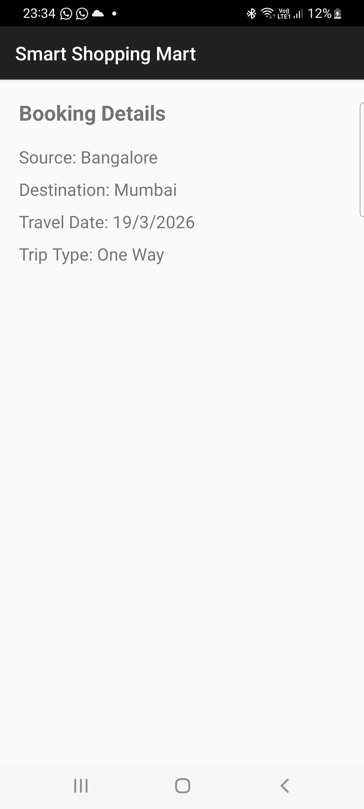
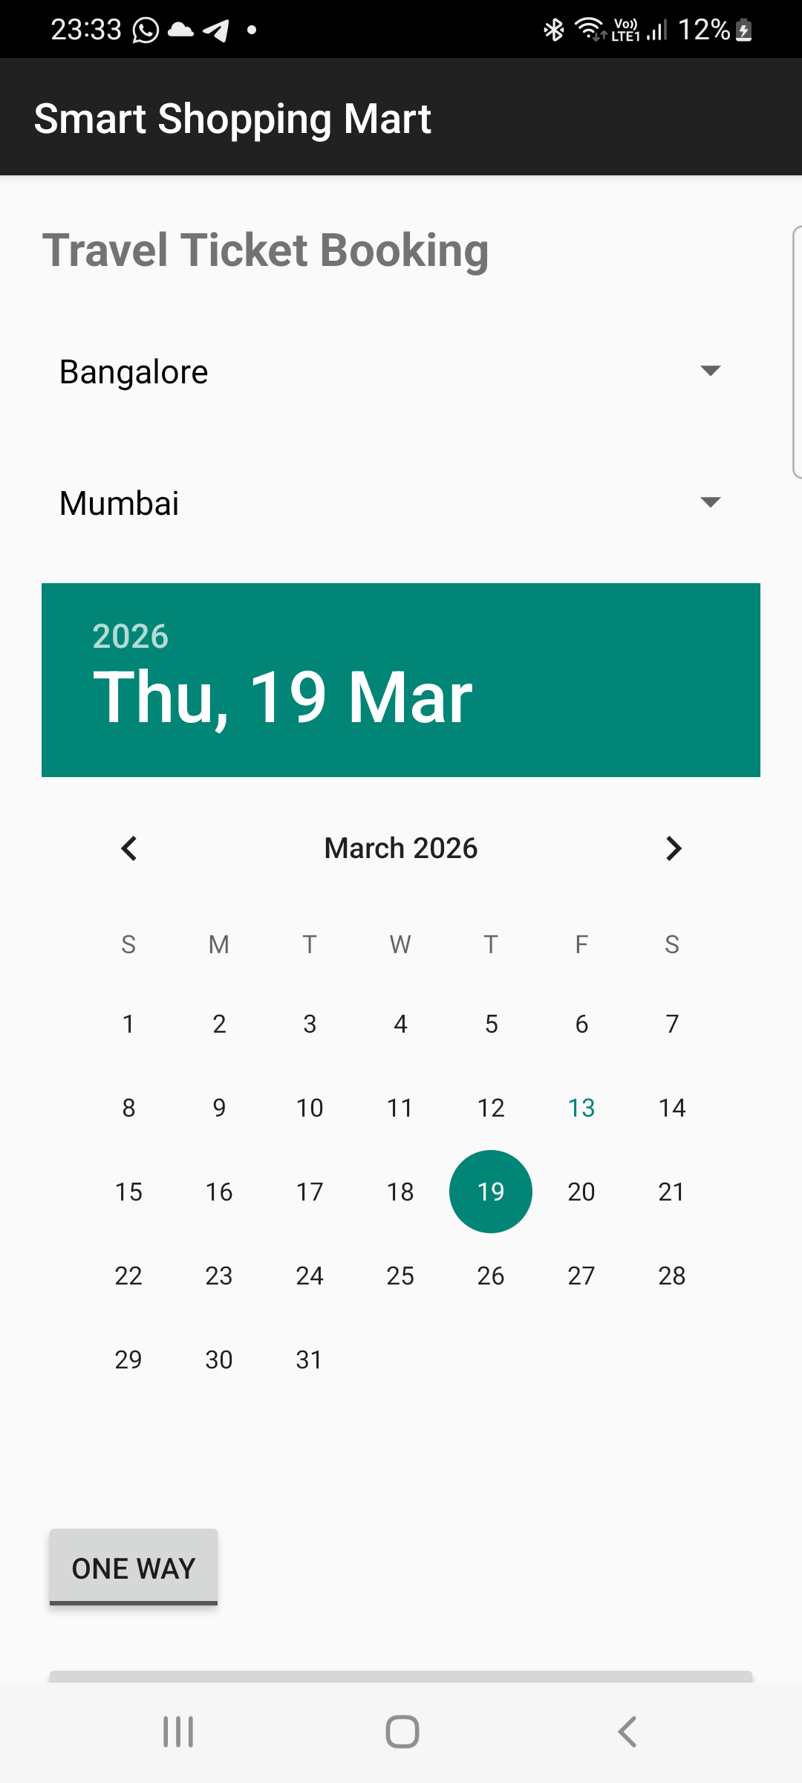

Q3. Design and develop a "Movie Ticket Booking" app where users can book tickets by selecting the movie and theatre from dropdown menus (spinners), the date of the show using a date picker, and the preferred showtime using a time picker. Include a toggle button to let users choose between a standard ticket or a premium ticket. If the "premium" option is selected, ensure the "Submit" button becomes clickable only after 12:00 PM. The app should have "Book Now" and "Reset" buttons. When the user clicks "Book Now," display the entered details along with available seats for the selected show in a new screen in a well-organized format. The "Reset" button should clear all fields and reset the date picker to the current system date. Validate all inputs to ensure correct data entry.

AndroidManifest.xml:
<?xml version="1.0" encoding="utf-8"?>
<manifest xmlns:android="http://schemas.android.com/apk/res/android"
package="com.example.myapplication">
<application
android:allowBackup="true"
android:label="Movie Ticket Booking"
android:theme="@style/Theme.AppCompat.Light.DarkActionBar">
<activity android:name=".ResultActivity"/>
<activity
android:name=".MainActivity"
android:exported="true">
<intent-filter>
<action android:name="android.intent.action.MAIN"/>
<category android:name="android.intent.category.LAUNCHER"/>
</intent-filter>
</activity>
</application>
</manifest>

MainActivtity.java:
package com.example.myapplication;
import android.app.DatePickerDialog;
import android.app.TimePickerDialog;
import android.content.Intent;
import android.os.Bundle;
import android.widget.*;
import androidx.appcompat.app.AppCompatActivity;
import java.util.Calendar;
import java.util.Random;
public class MainActivity extends AppCompatActivity {
Spinner spinnerMovie, spinnerTheatre;
Button btnDate, btnTime, btnBook, btnReset;
ToggleButton toggleTicket;
String selectedDate = "";
String selectedTime = "";
Calendar calendar;
@Override
protected void onCreate(Bundle savedInstanceState) {
super.onCreate(savedInstanceState);
setContentView(R.layout.activity_main);
spinnerMovie = findViewById(R.id.spinnerMovie);
spinnerTheatre = findViewById(R.id.spinnerTheatre);
btnDate = findViewById(R.id.btnDate);
btnTime = findViewById(R.id.btnTime);
btnBook = findViewById(R.id.btnBook);
btnReset = findViewById(R.id.btnReset);
toggleTicket = findViewById(R.id.toggleTicket);
calendar = Calendar.getInstance();
String[] movies = {"Avengers", "Inception", "Interstellar"};
String[] theatres = {"PVR", "INOX", "Cinepolis"};
ArrayAdapter<String> movieAdapter = new ArrayAdapter<>(
this, android.R.layout.simple_spinner_dropdown_item, movies);
spinnerMovie.setAdapter(movieAdapter);
ArrayAdapter<String> theatreAdapter = new ArrayAdapter<>(
this, android.R.layout.simple_spinner_dropdown_item, theatres);
spinnerTheatre.setAdapter(theatreAdapter);
// Date Picker
btnDate.setOnClickListener(v -> {
DatePickerDialog dp = new DatePickerDialog(this,
(view, year, month, day) -> {
selectedDate = day + "/" + (month + 1) + "/" + year;
btnDate.setText(selectedDate);
},
calendar.get(Calendar.YEAR),
calendar.get(Calendar.MONTH),
calendar.get(Calendar.DAY_OF_MONTH));
dp.show();
});
// Time Picker
btnTime.setOnClickListener(v -> {
TimePickerDialog tp = new TimePickerDialog(this,
(view, hour, minute) -> {
selectedTime = hour + ":" + minute;
btnTime.setText(selectedTime);
},
calendar.get(Calendar.HOUR_OF_DAY),
calendar.get(Calendar.MINUTE),
true);
tp.show();
});
// Premium rule
toggleTicket.setOnCheckedChangeListener((buttonView, isChecked) -> {
if (isChecked) {
int currentHour = Calendar.getInstance().get(Calendar.HOUR_OF_DAY);
if (currentHour < 12) {
btnBook.setEnabled(false);
Toast.makeText(this,
"Premium booking allowed only after 12 PM",
Toast.LENGTH_LONG).show();
} else {
btnBook.setEnabled(true);
}
} else {
btnBook.setEnabled(true);
}
});
// Book Now
btnBook.setOnClickListener(v -> {
if (selectedDate.isEmpty() || selectedTime.isEmpty()) {
Toast.makeText(this,
"Please select date and time",
Toast.LENGTH_SHORT).show();
return;
}
String movie = spinnerMovie.getSelectedItem().toString();
String theatre = spinnerTheatre.getSelectedItem().toString();
String ticketType = toggleTicket.isChecked() ? "Premium" : "Standard";
int seats = new Random().nextInt(50) + 1;
Intent intent = new Intent(MainActivity.this, ResultActivity.class);
intent.putExtra("movie", movie);
intent.putExtra("theatre", theatre);
intent.putExtra("date", selectedDate);
intent.putExtra("time", selectedTime);
intent.putExtra("ticketType", ticketType);
intent.putExtra("seats", seats);
startActivity(intent);
});
// Reset
btnReset.setOnClickListener(v -> {
spinnerMovie.setSelection(0);
spinnerTheatre.setSelection(0);
toggleTicket.setChecked(false);
selectedDate = "";
selectedTime = "";
btnDate.setText("Select Show Date");
btnTime.setText("Select Showtime");
});
}
}

ResultActivity.java:
package com.example.myapplication;
import android.os.Bundle;
import android.widget.TextView;
import androidx.appcompat.app.AppCompatActivity;
public class ResultActivity extends AppCompatActivity {
@Override
protected void onCreate(Bundle savedInstanceState) {
super.onCreate(savedInstanceState);
setContentView(R.layout.activity_result);
TextView textResult = findViewById(R.id.textResult);
String movie = getIntent().getStringExtra("movie");
String theatre = getIntent().getStringExtra("theatre");
String date = getIntent().getStringExtra("date");
String time = getIntent().getStringExtra("time");
String ticketType = getIntent().getStringExtra("ticketType");
int seats = getIntent().getIntExtra("seats", 0);
textResult.setText(
"----- Booking Details -----\n\n" +
"Movie: " + movie + "\n" +
"Theatre: " + theatre + "\n" +
"Date: " + date + "\n" +
"Time: " + time + "\n" +
"Ticket Type: " + ticketType + "\n" +
"Available Seats: " + seats
);
}
}

activity_main.xml:
<?xml version="1.0" encoding="utf-8"?>
<ScrollView xmlns:android="http://schemas.android.com/apk/res/android"
android:layout_width="match_parent"
android:layout_height="match_parent"
android:padding="16dp">
<LinearLayout
android:orientation="vertical"
android:layout_width="match_parent"
android:layout_height="wrap_content">
<TextView
android:text="Movie Ticket Booking"
android:textSize="20sp"
android:textStyle="bold"
android:layout_marginBottom="20dp"
android:layout_width="wrap_content"
android:layout_height="wrap_content"/>
<Spinner
android:id="@+id/spinnerMovie"
android:layout_width="match_parent"
android:layout_height="wrap_content"/>
<Spinner
android:id="@+id/spinnerTheatre"
android:layout_width="match_parent"
android:layout_height="wrap_content"
android:layout_marginTop="16dp"/>
<Button
android:id="@+id/btnDate"
android:text="Select Show Date"
android:layout_width="match_parent"
android:layout_height="wrap_content"
android:layout_marginTop="16dp"/>
<Button
android:id="@+id/btnTime"
android:text="Select Showtime"
android:layout_width="match_parent"
android:layout_height="wrap_content"
android:layout_marginTop="16dp"/>
<ToggleButton
android:id="@+id/toggleTicket"
android:textOn="Premium Ticket"
android:textOff="Standard Ticket"
android:layout_width="match_parent"
android:layout_height="wrap_content"
android:layout_marginTop="16dp"/>
<Button
android:id="@+id/btnBook"
android:text="Book Now"
android:layout_width="match_parent"
android:layout_height="wrap_content"
android:layout_marginTop="20dp"/>
<Button
android:id="@+id/btnReset"
android:text="Reset"
android:layout_width="match_parent"
android:layout_height="wrap_content"
android:layout_marginTop="10dp"/>
</LinearLayout>
</ScrollView>

Actvity_result.xml:
<?xml version="1.0" encoding="utf-8"?>
<LinearLayout xmlns:android="http://schemas.android.com/apk/res/android"
android:orientation="vertical"
android:padding="20dp"
android:layout_width="match_parent"
android:layout_height="match_parent">
<TextView
android:id="@+id/textResult"
android:textSize="18sp"
android:layout_width="match_parent"
android:layout_height="wrap_content"/>
</LinearLayout>

UI:
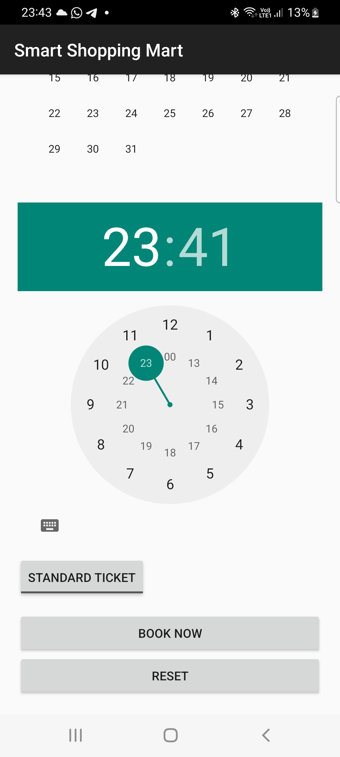
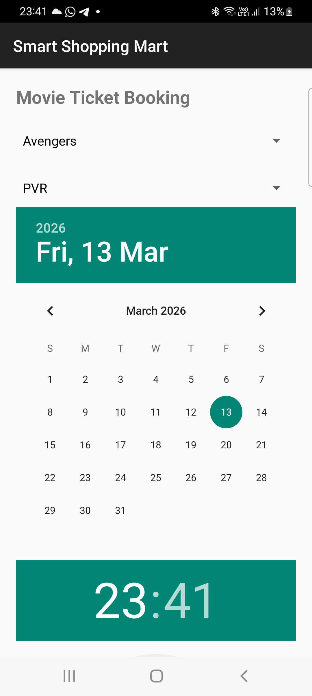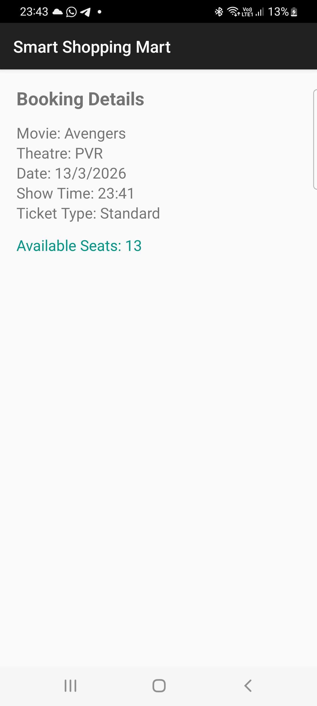

Lab6: INTRODUCTION TO MENU

.
Q1.Design a home page for the "XYZ Fitness Center" using an Options Menu with the
following Requirements.
a. Create a simple option menus where in once you click the “menu
options”, the option items should get displayed which are "Workout Plans,"
"Trainers," "Membership". "Workout Plans" should display the list of
workout programs (e.g., Weight Loss, Cardio). "Trainers" should display
the names and specializations of trainers with their photos.
"Membership" should show the membership packages with pricing
details.
b. This option menu uses images/icons instead of textual content. This
textual content should represent “Contact US”, “About Us”,” Homepage”.
Once the user clicks on the corresponding icons it should display
corresponding content

AndroidManifest.xml:
<?xml version="1.0" encoding="utf-8"?>
<manifest xmlns:android="http://schemas.android.com/apk/res/android"
package="com.example.myapplication">
<application
android:allowBackup="true"
android:label="XYZ Center"
android:theme="@style/Theme.AppCompat.Light.DarkActionBar">
<activity
android:name=".MainActivity"
android:exported="true">
<intent-filter>
<action android:name="android.intent.action.MAIN"/>
<category android:name="android.intent.category.LAUNCHER"/>
</intent-filter>
</activity>
</application>
</manifest>
MainActivity.java:
package com.example.myapplication;
import android.os.Bundle;
import android.view.Menu;
import android.view.MenuItem;
import android.widget.TextView;
import androidx.appcompat.app.AppCompatActivity;
import androidx.appcompat.widget.Toolbar;
public class MainActivity extends AppCompatActivity {
TextView txtContent;
@Override
protected void onCreate(Bundle savedInstanceState) {
super.onCreate(savedInstanceState);
setContentView(R.layout.activity_main);
txtContent = findViewById(R.id.txtContent);
}
@Override
public boolean onCreateOptionsMenu(Menu menu) {
getMenuInflater().inflate(R.menu.menu_main, menu);
return true;
}
@Override
public boolean onOptionsItemSelected(MenuItem item) {
int id = item.getItemId();
if (id == R.id.workout) {
txtContent.setText(
" Workout Plans\n\n" +
"• Weight Loss\n" +
"• Cardio\n" +
"• Muscle Gain"
);
}
else if (id == R.id.trainers) {
txtContent.setText(
" Trainers\n\n" +
"• John – Strength Training\n" +
"• Sarah – Cardio Specialist"
);
}
else if (id == R.id.membership) {
txtContent.setText("Membership:\nBasic - ₹2000/month\nPremium - ₹3500/month");
}
else if (id == R.id.home) {
txtContent.setText("Welcome to XYZ Fitness Center!");
}
else if (id == R.id.about) {
txtContent.setText("About Us:\nWe provide professional fitness training.");
}
else if (id == R.id.contact) {
txtContent.setText("Contact Us:\nPhone: 9876543210\nEmail: xyzfitness@gmail.com");
}
return true;
}
}

activity_main.xml:
<?xml version="1.0" encoding="utf-8"?>
<LinearLayout
xmlns:android="http://schemas.android.com/apk/res/android"
xmlns:app="http://schemas.android.com/apk/res-auto"
android:orientation="vertical"
android:layout_width="match_parent"
android:layout_height="match_parent"
android:background="#F5F5F5">
<androidx.appcompat.widget.Toolbar
android:id="@+id/toolbar"
android:layout_width="match_parent"
android:layout_height="56dp"
android:background="#1E1E1E"
android:elevation="6dp"
android:title="XYZ Fitness Center"
android:titleTextColor="@android:color/white"/>
<TextView
android:id="@+id/txtContent"
android:layout_margin="16dp"
android:padding="16dp"
android:textSize="18sp"
android:textColor="#333333"
android:background="@android:color/white"
android:elevation="4dp"
android:layout_width="match_parent"
android:layout_height="wrap_content"/>
</LinearLayout>

Res-> menu-> menu_main.xml:
<?xml version="1.0" encoding="utf-8"?>
<menu xmlns:android="http://schemas.android.com/apk/res/android"
xmlns:app="http://schemas.android.com/apk/res-auto">
<item
android:id="@+id/workout"
android:title="Workout Plans" />
<item
android:id="@+id/trainers"
android:title="Trainers" />
<item
android:id="@+id/membership"
android:title="Membership" />
<item
android:id="@+id/home"
android:icon="@drawable/home"
android:title="Home"
app:showAsAction="always" />
<item
android:id="@+id/about"
android:icon="@drawable/about"
android:title="About"
app:showAsAction="always" />
<item
android:id="@+id/contact"
android:icon="@drawable/contact"
android:title="Contact"
app:showAsAction="always" />
</menu>

Res-> values-> themes-> themes.xml:
<resources xmlns:tools="http://schemas.android.com/tools">
<style name="Theme.MyApplication" parent="Theme.MaterialComponents.DayNight.NoActionBar">
<item name="colorPrimary">@color/purple_500</item>
<item name="colorPrimaryVariant">@color/purple_700</item>
<item name="colorOnPrimary">@color/white</item>
<item name="colorSecondary">@color/teal_200</item>
<item name="colorSecondaryVariant">@color/teal_700</item>
<item name="colorOnSecondary">@color/black</item>
<item name="android:statusBarColor">?attr/colorPrimaryVariant</item>
</style>
</resources>

Values->colors.xml:
<?xml version="1.0" encoding="utf-8"?>
<resources>
<color name="purple_500">#6200EE</color>
<color name="purple_700">#3700B3</color>
<color name="teal_200">#03DAC5</color>
<color name="teal_700">#018786</color>
<color name="black">#000000</color>
<color name="white">#FFFFFF</color>
</resources>
UI:

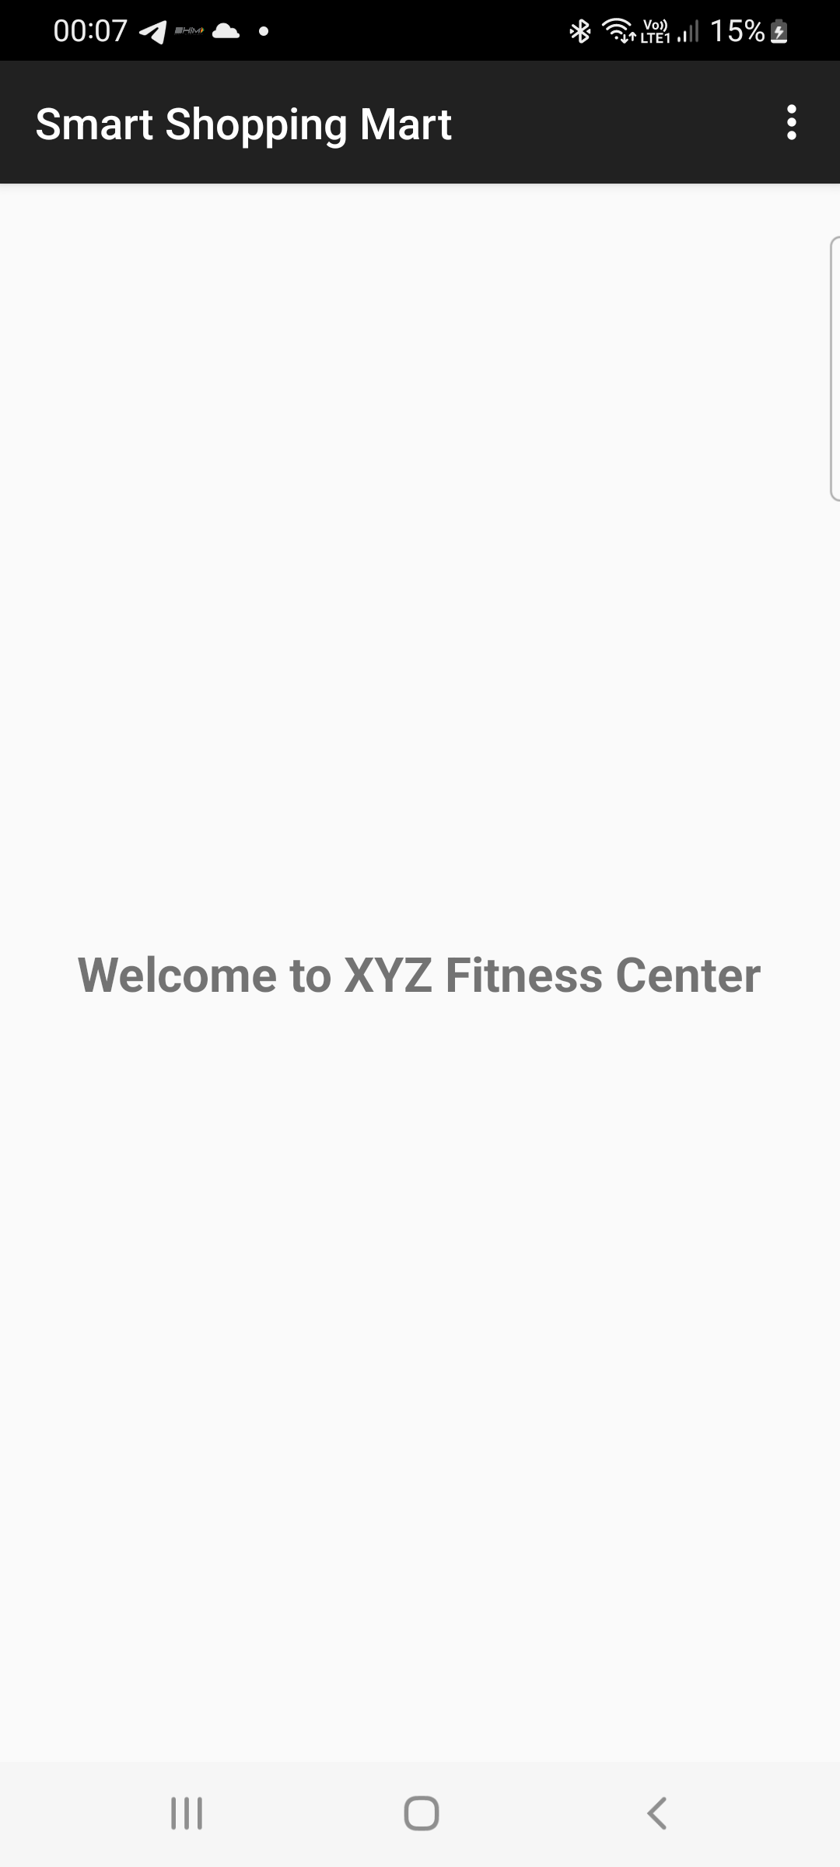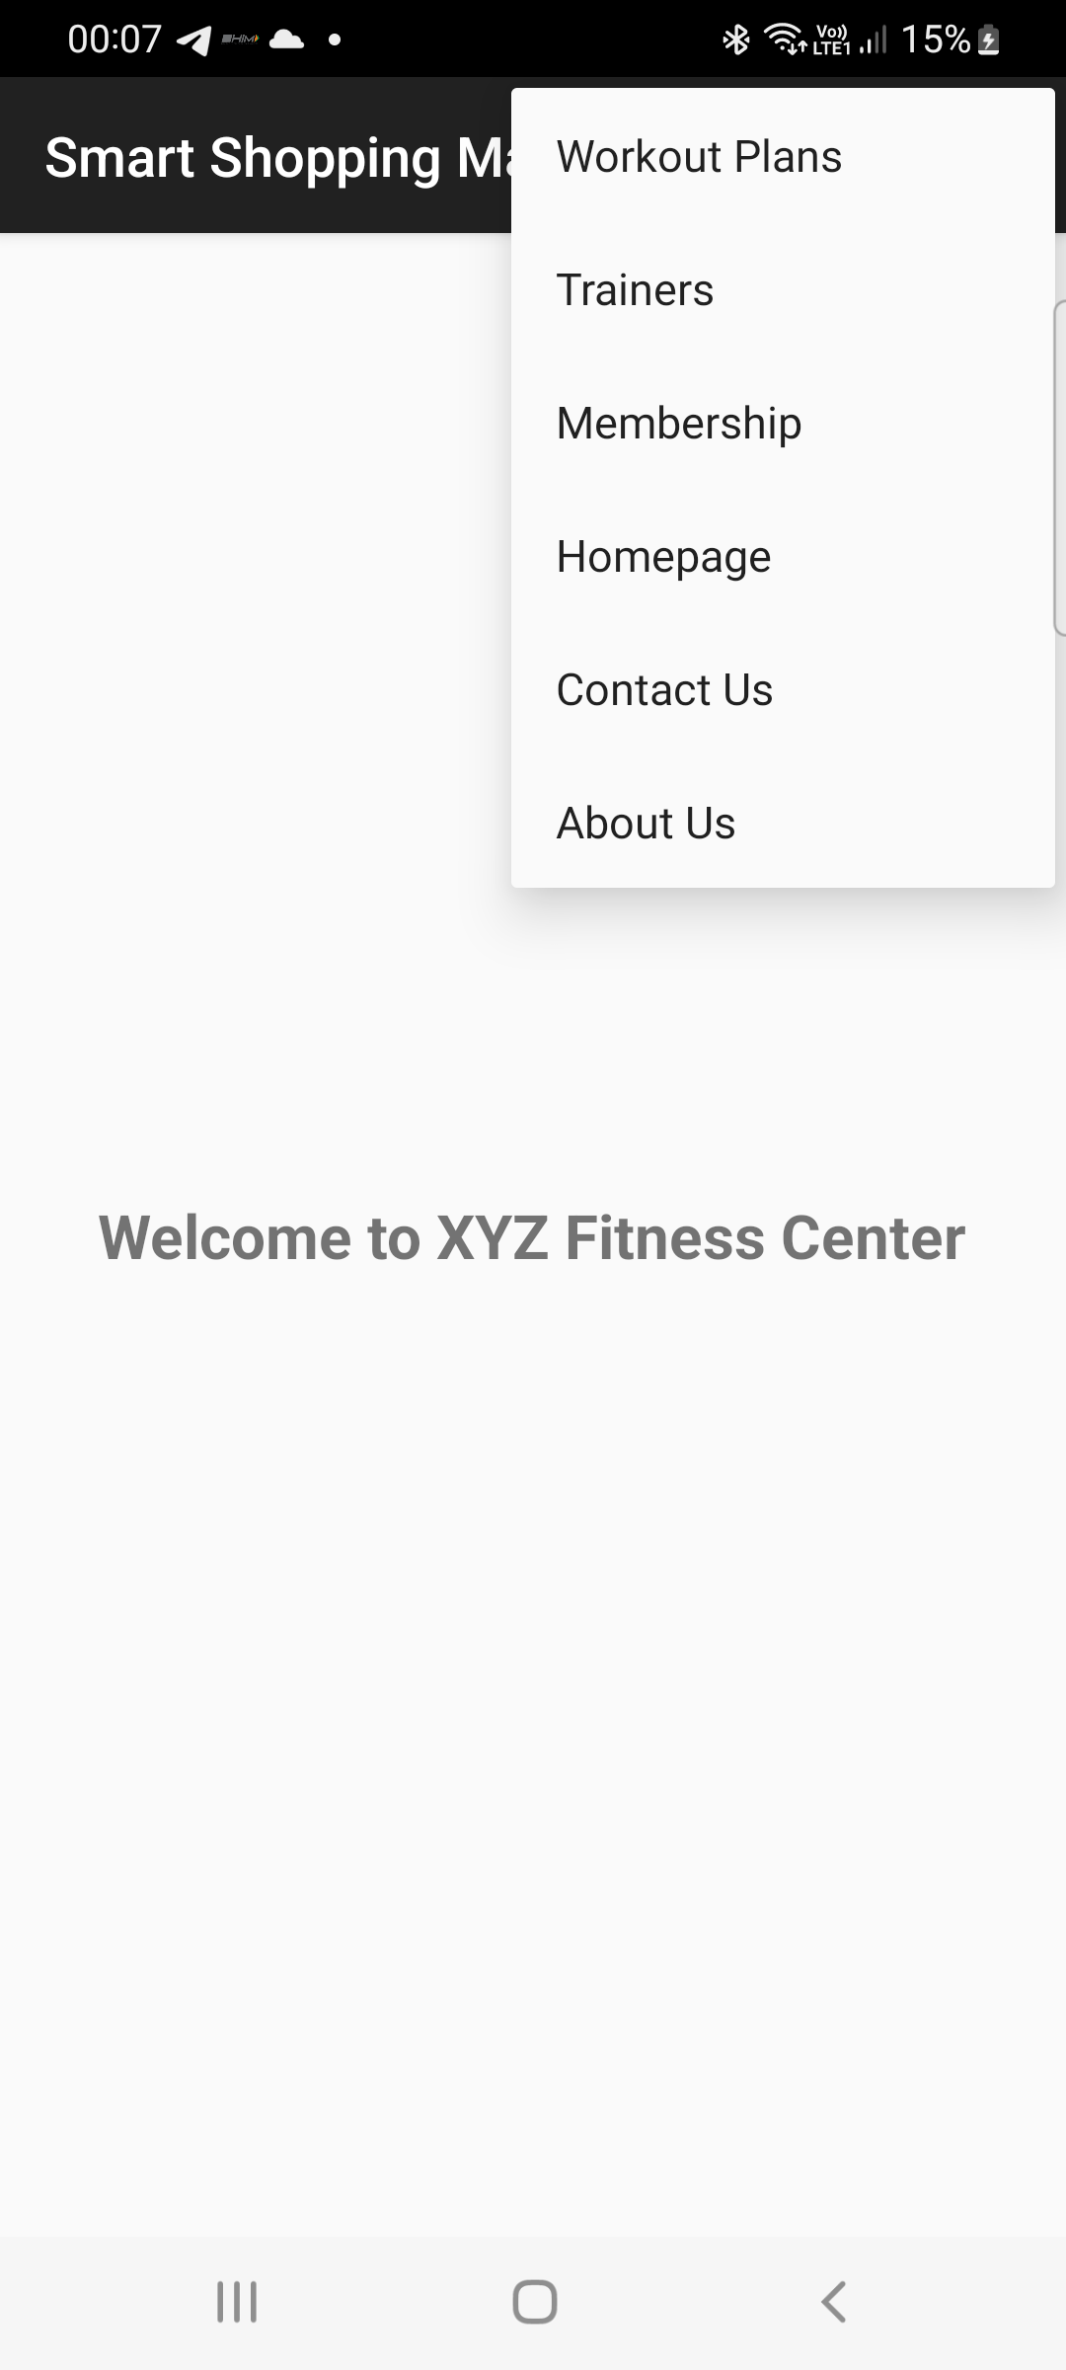
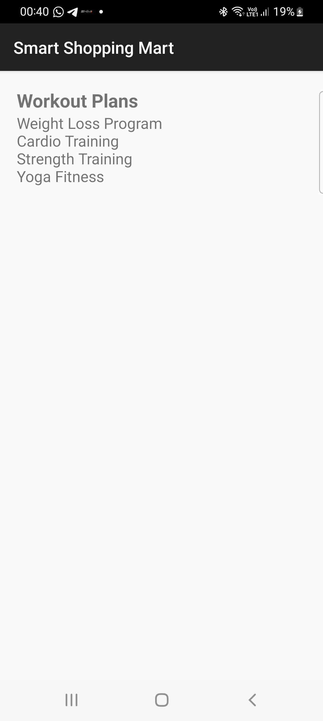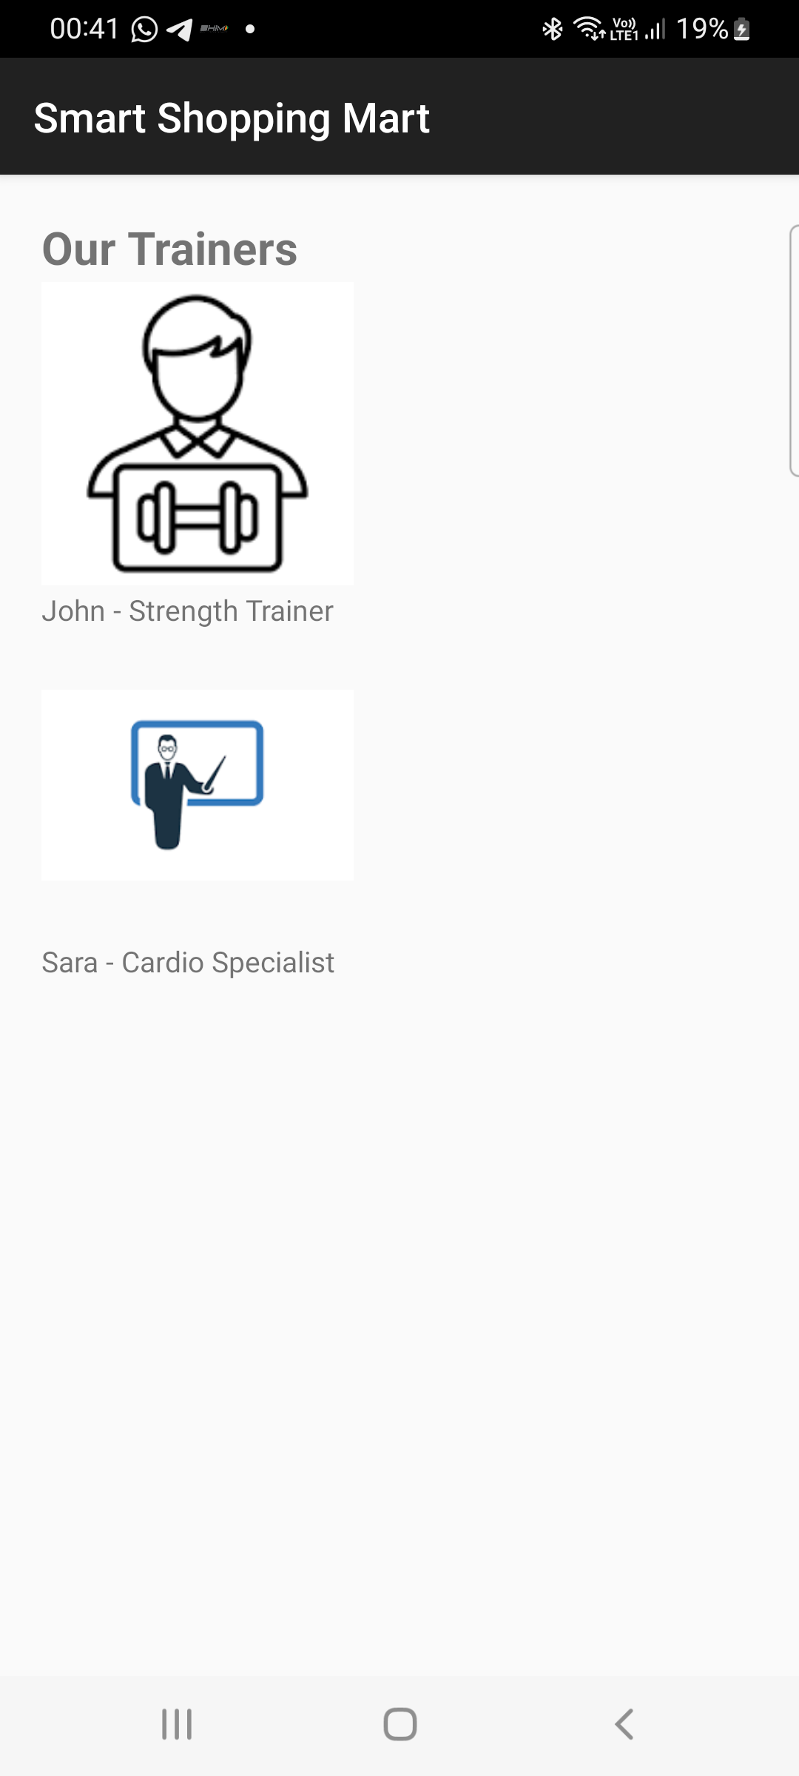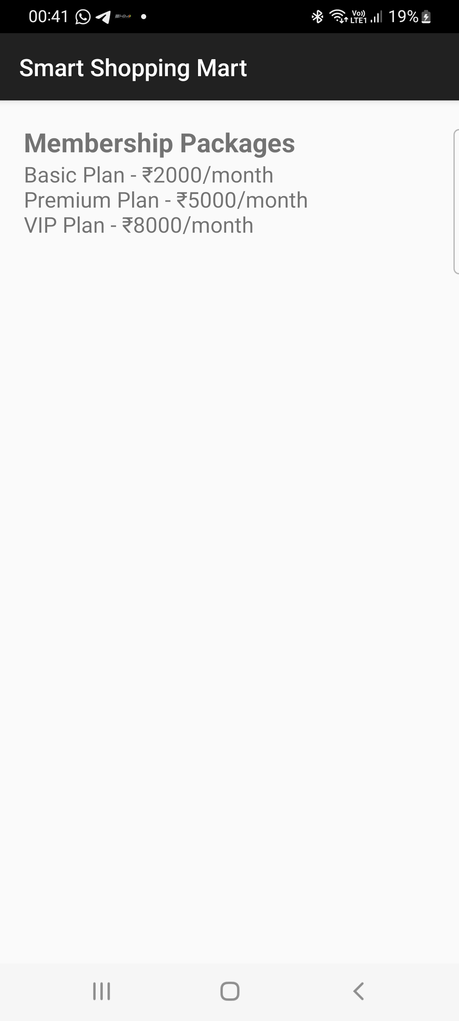

Lab7: CREATING CONTEXTUAL AND POP-UP MENUS

Q1. Design and develop an application that displays a list of installed applications on your device. On long press of any application, display the following options: a) Show whether the application is a system app or user-installed. b) Provide options to open the app, uninstall it, or view its details (e.g., version, storage usage). c) Indicate whether the app has special permissions enabled, like location or camera access. When an option like "View Details" is selected, navigate to a detailed view showing the app's permissions, size, and version. For the "Uninstall" option, prompt the user for confirmation before proceeding.

AndroidManifest.xml
<manifest xmlns:android="http://schemas.android.com/apk/res/android"
package="com.example.applist">

<uses-permission android:name="android.permission.QUERY_ALL_PACKAGES"/>

<application
android:theme="@style/Theme.AppCompat.Light.DarkActionBar"
android:label="Installed Apps">

<activity android:name=".AppDetailsActivity"/>
<activity android:name=".MainActivity">
<intent-filter>
<action android:name="android.intent.action.MAIN"/>
<category android:name="android.intent.category.LAUNCHER"/>
</intent-filter>
</activity>

</application>
</manifest>

activity_main.xml
<LinearLayout xmlns:android="http://schemas.android.com/apk/res/android"
android:layout_width="match_parent"
android:layout_height="match_parent">

<ListView
android:id="@+id/listView"
android:layout_width="match_parent"
android:layout_height="match_parent"/>
</LinearLayout>

MainActivity.java
package com.example.applist;

import android.app.AlertDialog;
import android.content.Intent;
import android.content.pm.ApplicationInfo;
import android.content.pm.PackageManager;
import android.net.Uri;
import android.os.Bundle;
import android.widget.ArrayAdapter;
import android.widget.ListView;
import android.widget.Toast;

import androidx.appcompat.app.AppCompatActivity;

import java.util.ArrayList;
import java.util.List;

public class MainActivity extends AppCompatActivity {

ListView listView;
PackageManager pm;
List<ApplicationInfo> apps;
List<String> appNames;

@Override
protected void onCreate(Bundle savedInstanceState) {
super.onCreate(savedInstanceState);
setContentView(R.layout.activity_main);

listView = findViewById(R.id.listView);
pm = getPackageManager();

apps = pm.getInstalledApplications(PackageManager.GET_META_DATA);
appNames = new ArrayList<>();

for (ApplicationInfo app : apps) {
appNames.add(pm.getApplicationLabel(app).toString());
}

ArrayAdapter<String> adapter =
new ArrayAdapter<>(this,
android.R.layout.simple_list_item_1,
appNames);

listView.setAdapter(adapter);

listView.setOnItemLongClickListener((parent, view, position, id) -> {
showOptions(position);
return true;
});
}

private void showOptions(int position) {
ApplicationInfo app = apps.get(position);

String[] options = {
"App Type",
"Open App",
"Uninstall App",
"View Details"
};

new AlertDialog.Builder(this)
.setTitle(pm.getApplicationLabel(app))
.setItems(options, (dialog, which) -> {

switch (which) {

case 0: // System or User
boolean isSystem =
(app.flags & ApplicationInfo.FLAG_SYSTEM) != 0;
Toast.makeText(this,
isSystem ? "System App" : "User Installed App",
Toast.LENGTH_SHORT).show();
break;

case 1: // Open
Intent launch =
pm.getLaunchIntentForPackage(app.packageName);
if (launch != null)
startActivity(launch);
break;

case 2: // Uninstall
confirmUninstall(app.packageName);
break;

case 3: // View details
Intent intent =
new Intent(this, AppDetailsActivity.class);
intent.putExtra("pkg", app.packageName);
startActivity(intent);
break;
}
})
.show();
}

private void confirmUninstall(String pkg) {
new AlertDialog.Builder(this)
.setTitle("Uninstall")
.setMessage("Are you sure?")
.setPositiveButton("Yes", (d, w) -> {
Intent i = new Intent(Intent.ACTION_DELETE);
i.setData(Uri.parse("package:" + pkg));
startActivity(i);
})
.setNegativeButton("No", null)
.show();
}
}

activity_details.xml

<LinearLayout xmlns:android="http://schemas.android.com/apk/res/android"
android:orientation="vertical"
android:padding="16dp"
android:layout_width="match_parent"
android:layout_height="match_parent">

<TextView android:id="@+id/tvName"/>
<TextView android:id="@+id/tvVersion"/>
<TextView android:id="@+id/tvSize"/>
<TextView android:id="@+id/tvPermissions"/>
</LinearLayout>

AppDetailsActivity.java
package com.example.applist;

import android.content.pm.PackageInfo;
import android.content.pm.PackageManager;
import android.os.Bundle;
import android.widget.TextView;

import androidx.appcompat.app.AppCompatActivity;

import java.io.File;

public class AppDetailsActivity extends AppCompatActivity {

@Override
protected void onCreate(Bundle savedInstanceState) {
super.onCreate(savedInstanceState);
setContentView(R.layout.activity_details);

TextView tvName = findViewById(R.id.tvName);
TextView tvVersion = findViewById(R.id.tvVersion);
TextView tvSize = findViewById(R.id.tvSize);
TextView tvPermissions = findViewById(R.id.tvPermissions);

String pkg = getIntent().getStringExtra("pkg");

try {
PackageManager pm = getPackageManager();
PackageInfo info =
pm.getPackageInfo(pkg, PackageManager.GET_PERMISSIONS);

tvName.setText("App: " +
pm.getApplicationLabel(info.applicationInfo));

tvVersion.setText("Version: " + info.versionName);

File file =
new File(info.applicationInfo.sourceDir);
long size = file.length() / (1024 * 1024);
tvSize.setText("Size: " + size + " MB");

StringBuilder perms = new StringBuilder("Permissions:\n");

if (info.requestedPermissions != null) {
for (String p : info.requestedPermissions) {
if (p.contains("CAMERA") || p.contains("LOCATION"))
perms.append(p).append("\n");
}
}

tvPermissions.setText(perms.toString());

} catch (Exception e) {
e.printStackTrace();
}
}
}
UI:
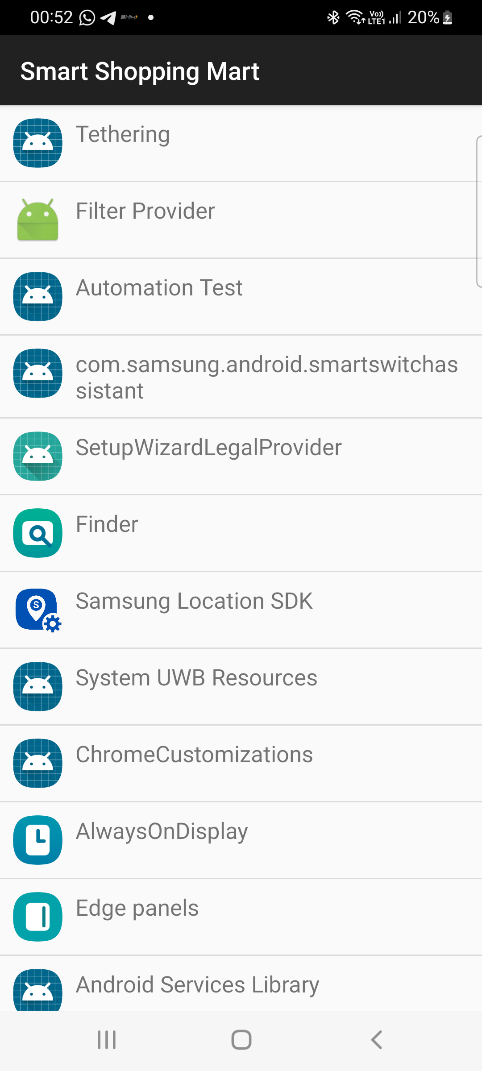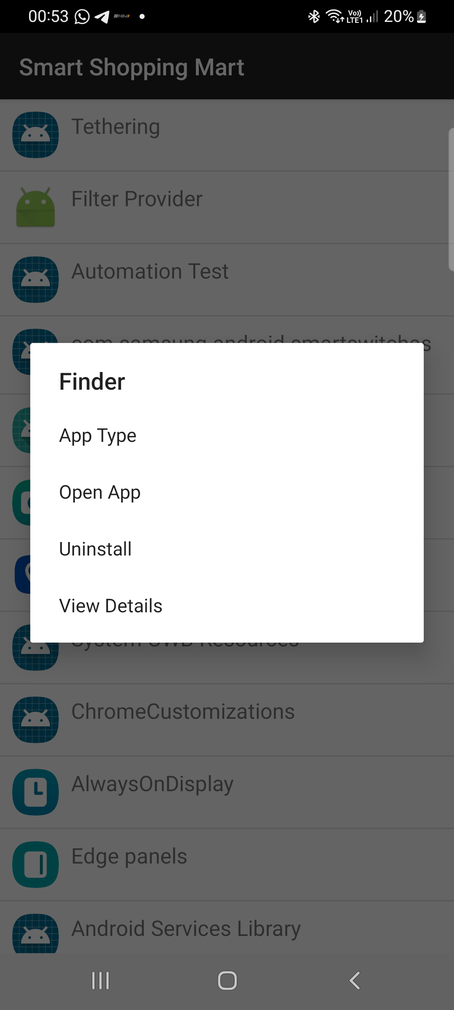

Q2. Create a View with the name “My Menu ” which contains an image as an icon.On click of that icon it shows a submenu as ”Image -1”,”Image -2” .On click of each item that particular image should be displayed with the corresponding content in the Toast.

AndroidManifest.xml:
<?xml version="1.0" encoding="utf-8"?>
<manifest xmlns:android="http://schemas.android.com/apk/res/android"
package="com.example.myapplication">
<application
android:allowBackup="true"
android:label="My Menu"
android:theme="@style/Theme.AppCompat.Light.DarkActionBar">
<activity
android:name=".MainActivity"
android:exported="true">
<intent-filter>
<action android:name="android.intent.action.MAIN"/>
<category android:name="android.intent.category.LAUNCHER"/>
</intent-filter>
</activity>
</application>
</manifest>

MainActivity.java:
package com.example.myapplication;
import android.os.Bundle;
import android.widget.ImageView;
import android.widget.PopupMenu;
import android.widget.Toast;
import androidx.appcompat.app.AppCompatActivity;
public class MainActivity extends AppCompatActivity {
ImageView menuIcon, displayImage;
@Override
protected void onCreate(Bundle savedInstanceState) {
super.onCreate(savedInstanceState);
setContentView(R.layout.activity_main);
menuIcon = findViewById(R.id.menuIcon);
displayImage = findViewById(R.id.displayImage);
menuIcon.setOnClickListener(view -> {
PopupMenu popupMenu =
new PopupMenu(MainActivity.this, view);
popupMenu.getMenuInflater()
.inflate(R.menu.popup_menu, popupMenu.getMenu());
popupMenu.setOnMenuItemClickListener(item -> {
if (item.getItemId() == R.id.image1) {
displayImage.setImageResource(
android.R.drawable.ic_menu_camera);
Toast.makeText(MainActivity.this,
"Image - 1 Selected",
Toast.LENGTH_SHORT).show();
return true;
}
else if (item.getItemId() == R.id.image2) {
displayImage.setImageResource(
android.R.drawable.ic_menu_gallery);
Toast.makeText(MainActivity.this,
"Image - 2 Selected",
Toast.LENGTH_SHORT).show();
return true;
}
return false;
});
popupMenu.show();
});
}
}

activty_main.xml:
<?xml version="1.0" encoding="utf-8"?>
<LinearLayout xmlns:android="http://schemas.android.com/apk/res/android"
android:layout_width="match_parent"
android:layout_height="match_parent"
android:orientation="vertical"
android:gravity="center"
android:padding="16dp">
<!-- Title -->
<TextView
android:layout_width="wrap_content"
android:layout_height="wrap_content"
android:text="My Menu"
android:textSize="22sp"
android:layout_marginBottom="20dp"/>
<!-- Menu Icon -->
<ImageView
android:id="@+id/menuIcon"
android:layout_width="100dp"
android:layout_height="100dp"
android:src="@android:drawable/ic_menu_more"
android:contentDescription="Menu Icon"/>
<!-- Display Image -->
<ImageView
android:id="@+id/displayImage"
android:layout_width="200dp"
android:layout_height="200dp"
android:layout_marginTop="30dp"/>
</LinearLayout>

Res->menu->popup_menu.xml:
<?xml version="1.0" encoding="utf-8"?>
<menu xmlns:android="http://schemas.android.com/apk/res/android">
<item
android:id="@+id/image1"
android:title="Image - 1"/>
<item
android:id="@+id/image2"
android:title="Image - 2"/>
</menu>

UI:
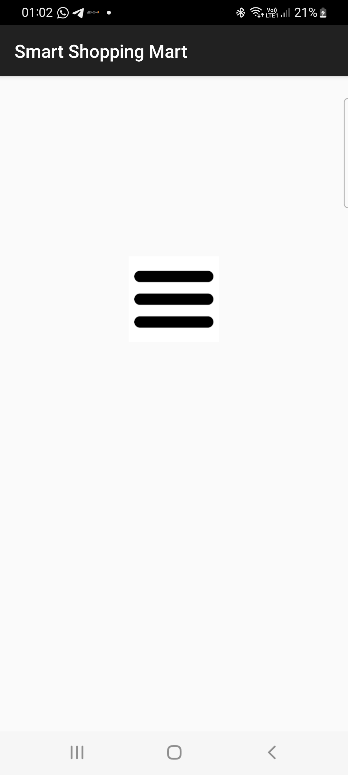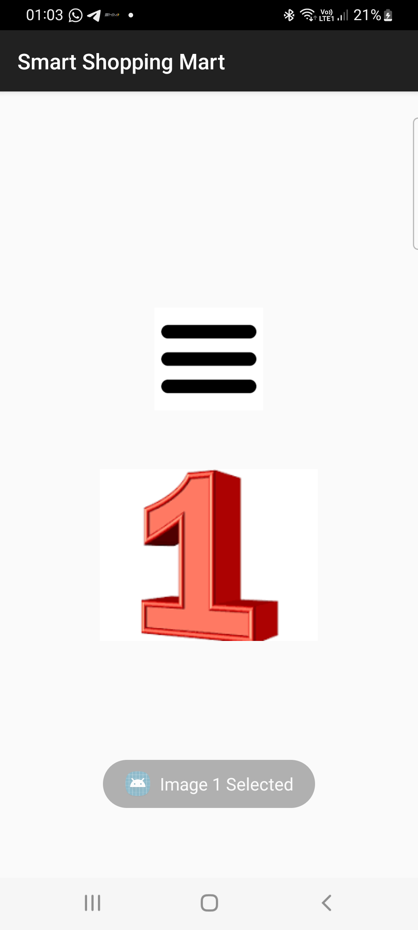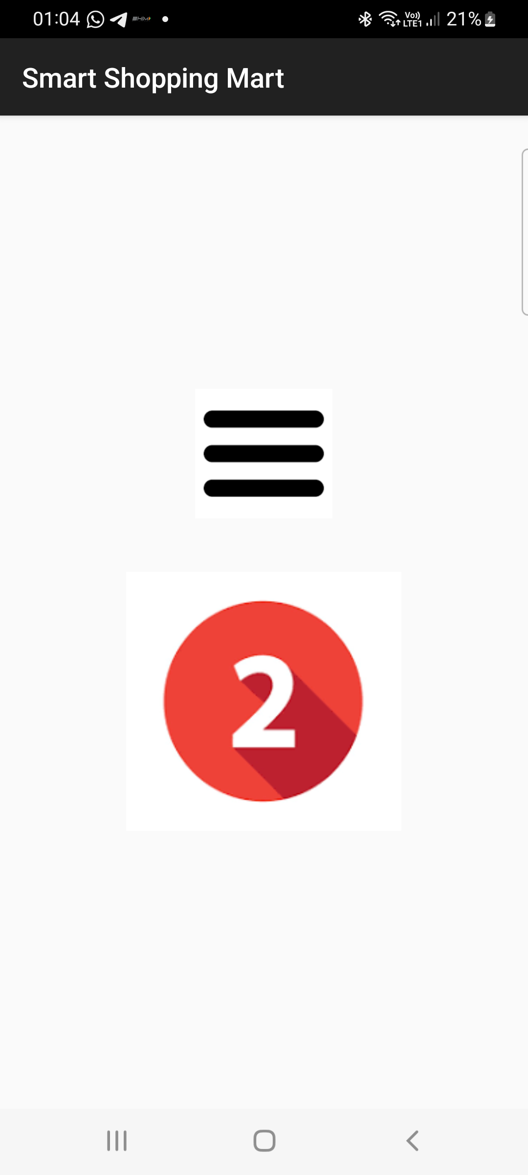

Q3. Create a view that displays textual content providing a description of "Digital Transformation". Add a filter option with submenus: a. "Search Keywords" - Allow the user to input keywords that can be searched within the content. b. "Highlight" - Highlight specific words or phrases provided by the user in the document. c. "Sort" - Provide an option to sort the entire content either alphabetically or by relevance to the search keywords.

AndroidManifest.xml:
<?xml version="1.0" encoding="utf-8"?>
<manifest xmlns:android="http://schemas.android.com/apk/res/android"
package="com.example.myapplication">
<application
android:allowBackup="true"
android:label="Digital Transformation"
android:theme="@style/Theme.AppCompat.Light.DarkActionBar">
<activity
android:name=".MainActivity"
android:exported="true">
<intent-filter>
<action android:name="android.intent.action.MAIN"/>
<category android:name="android.intent.category.LAUNCHER"/>
</intent-filter>
</activity>
</application>
</manifest>

MainActivity.java:
package com.example.myapplication;
import android.app.AlertDialog;
import android.os.Bundle;
import android.text.SpannableString;
import android.text.style.BackgroundColorSpan;
import android.view.Menu;
import android.view.MenuItem;
import android.widget.EditText;
import android.widget.TextView;
import androidx.appcompat.app.AppCompatActivity;
import android.graphics.Color;
public class MainActivity extends AppCompatActivity {
TextView textContent;
String content;
@Override
protected void onCreate(Bundle savedInstanceState) {
super.onCreate(savedInstanceState);
setContentView(R.layout.activity_main);
textContent = findViewById(R.id.textContent);
content = textContent.getText().toString();
}
// menu
@Override
public boolean onCreateOptionsMenu(Menu menu) {
getMenuInflater().inflate(R.menu.menu_filter, menu);
return true;
}
// menu click actions
@Override
public boolean onOptionsItemSelected(MenuItem item) {
if(item.getItemId() == R.id.search_keyword){
searchKeyword();
}
else if(item.getItemId() == R.id.highlight){
highlightWord();
}
else if(item.getItemId() == R.id.sort_alpha){
sortAlphabetically();
}
else if(item.getItemId() == R.id.sort_relevance){
sortRelevance();
}
return super.onOptionsItemSelected(item);
}
// SEARCH
void searchKeyword(){
EditText input = new EditText(this);
new AlertDialog.Builder(this)
.setTitle("Search Keyword")
.setView(input)
.setPositiveButton("Search",(dialog, which) -> {
String keyword = input.getText().toString();
if(content.toLowerCase().contains(keyword.toLowerCase())){
textContent.setText("Keyword Found:\n\n"+content);
}else{
textContent.setText("Keyword Not Found");
}
})
.setNegativeButton("Cancel",null)
.show();
}
// HIGHLIGHT
void highlightWord(){
EditText input = new EditText(this);
new AlertDialog.Builder(this)
.setTitle("Highlight Word")
.setView(input)
.setPositiveButton("Highlight",(dialog, which) -> {
String word = input.getText().toString();
SpannableString spannable = new SpannableString(content);
int index = content.toLowerCase().indexOf(word.toLowerCase());
while(index >= 0){
spannable.setSpan(
new BackgroundColorSpan(Color.YELLOW),
index,
index + word.length(),
0
);
index = content.toLowerCase().indexOf(word.toLowerCase(), index + word.length());
}
textContent.setText(spannable);
})
.setNegativeButton("Cancel",null)
.show();
}
// SORT ALPHABETICALLY
void sortAlphabetically(){
String[] words = content.split(" ");
java.util.Arrays.sort(words);
String sorted = "";
for(String w : words){
sorted += w + " ";
}
textContent.setText(sorted);
}
// SORT BY RELEVANCE
void sortRelevance(){
String[] words = content.split(" ");
java.util.Arrays.sort(words, (a,b)-> b.length()-a.length());
String sorted = "";
for(String w : words){
sorted += w + " ";
}
textContent.setText(sorted);
}
}

activity_main.xml:
<?xml version="1.0" encoding="utf-8"?>
<LinearLayout xmlns:android="http://schemas.android.com/apk/res/android"
android:layout_width="match_parent"
android:layout_height="match_parent"
android:padding="16dp"
android:orientation="vertical">
<ScrollView
android:layout_width="match_parent"
android:layout_height="match_parent">
<TextView
android:id="@+id/textContent"
android:layout_width="match_parent"
android:layout_height="wrap_content"
android:textSize="18sp"
android:text="Digital Transformation is the integration of digital technology into all areas of business. It changes how organizations operate and deliver value to customers. Technologies like AI, cloud computing, and big data drive innovation and efficiency. Digital transformation also improves decision making, customer experience, and operational efficiency." />
</ScrollView>
</LinearLayout>

Res-> menu->menu_filter.xml:
<?xml version="1.0" encoding="utf-8"?>
<menu xmlns:android="http://schemas.android.com/apk/res/android">
<item
android:title="Filter">
<menu>
<item
android:id="@+id/search_keyword"
android:title="Search Keywords"/>
<item
android:id="@+id/highlight"
android:title="Highlight"/>
<item
android:title="Sort">
<menu>
<item
android:id="@+id/sort_alpha"
android:title="Alphabetical"/>
<item
android:id="@+id/sort_relevance"
android:title="By Relevance"/>
</menu>
</item>
</menu>
</item>
</menu>

UI:

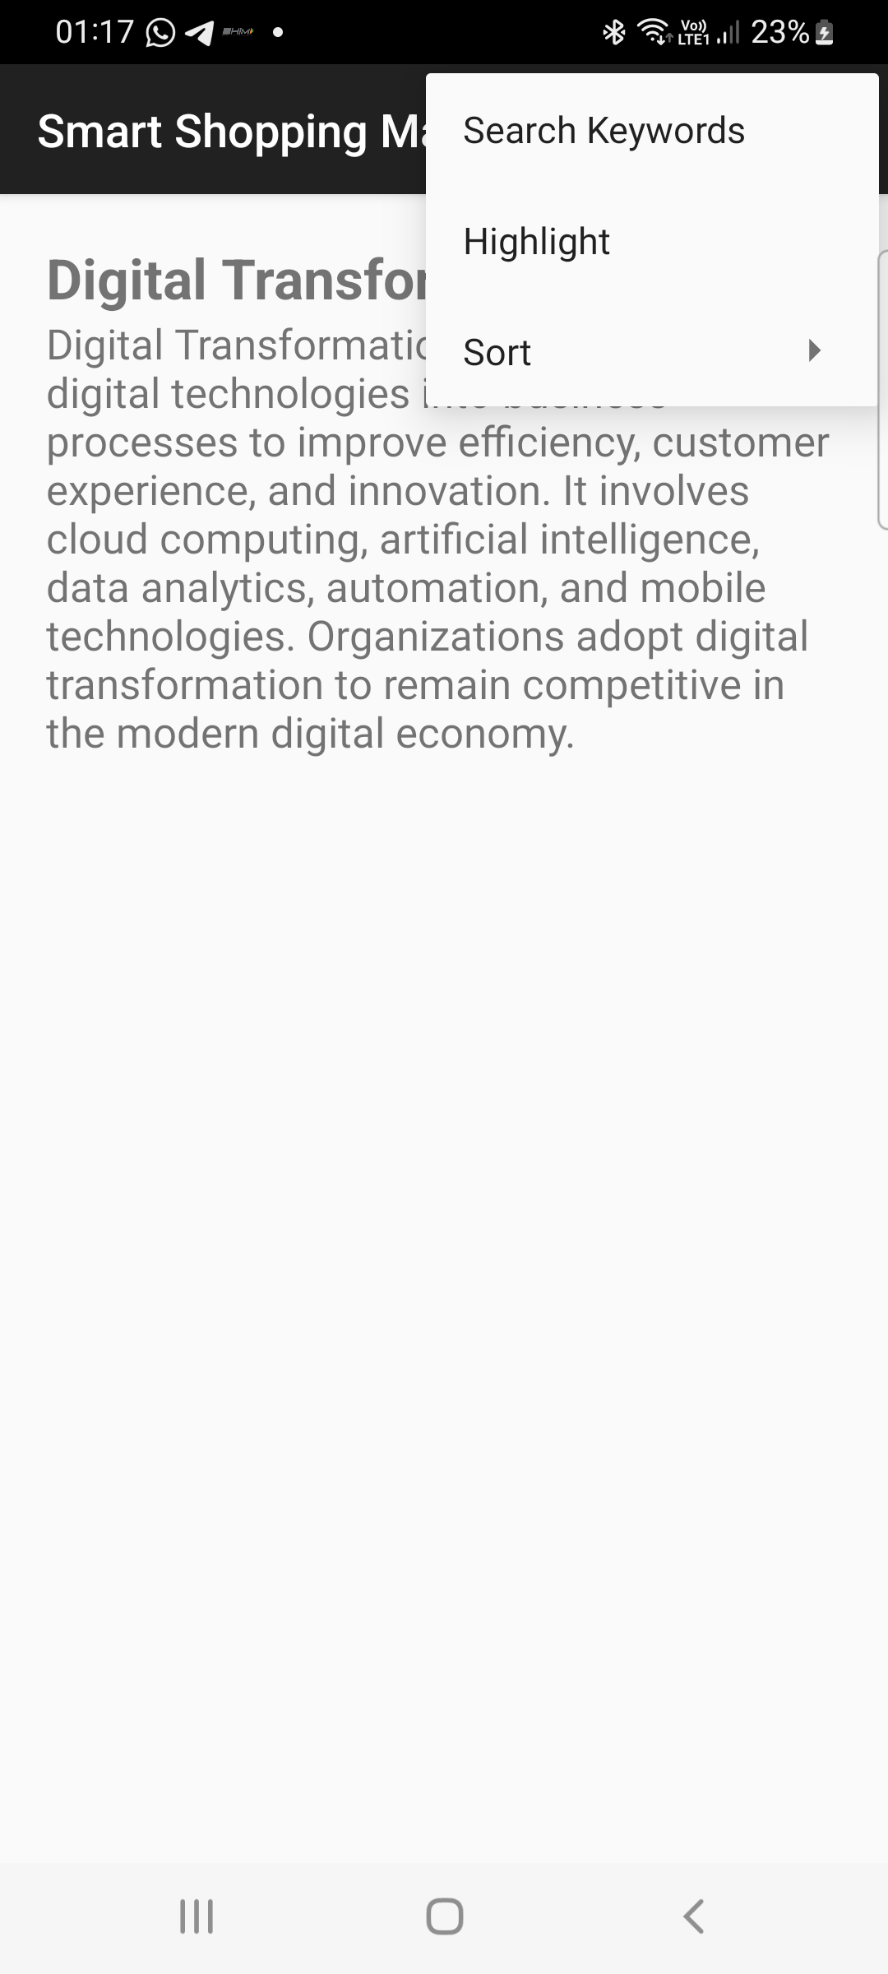
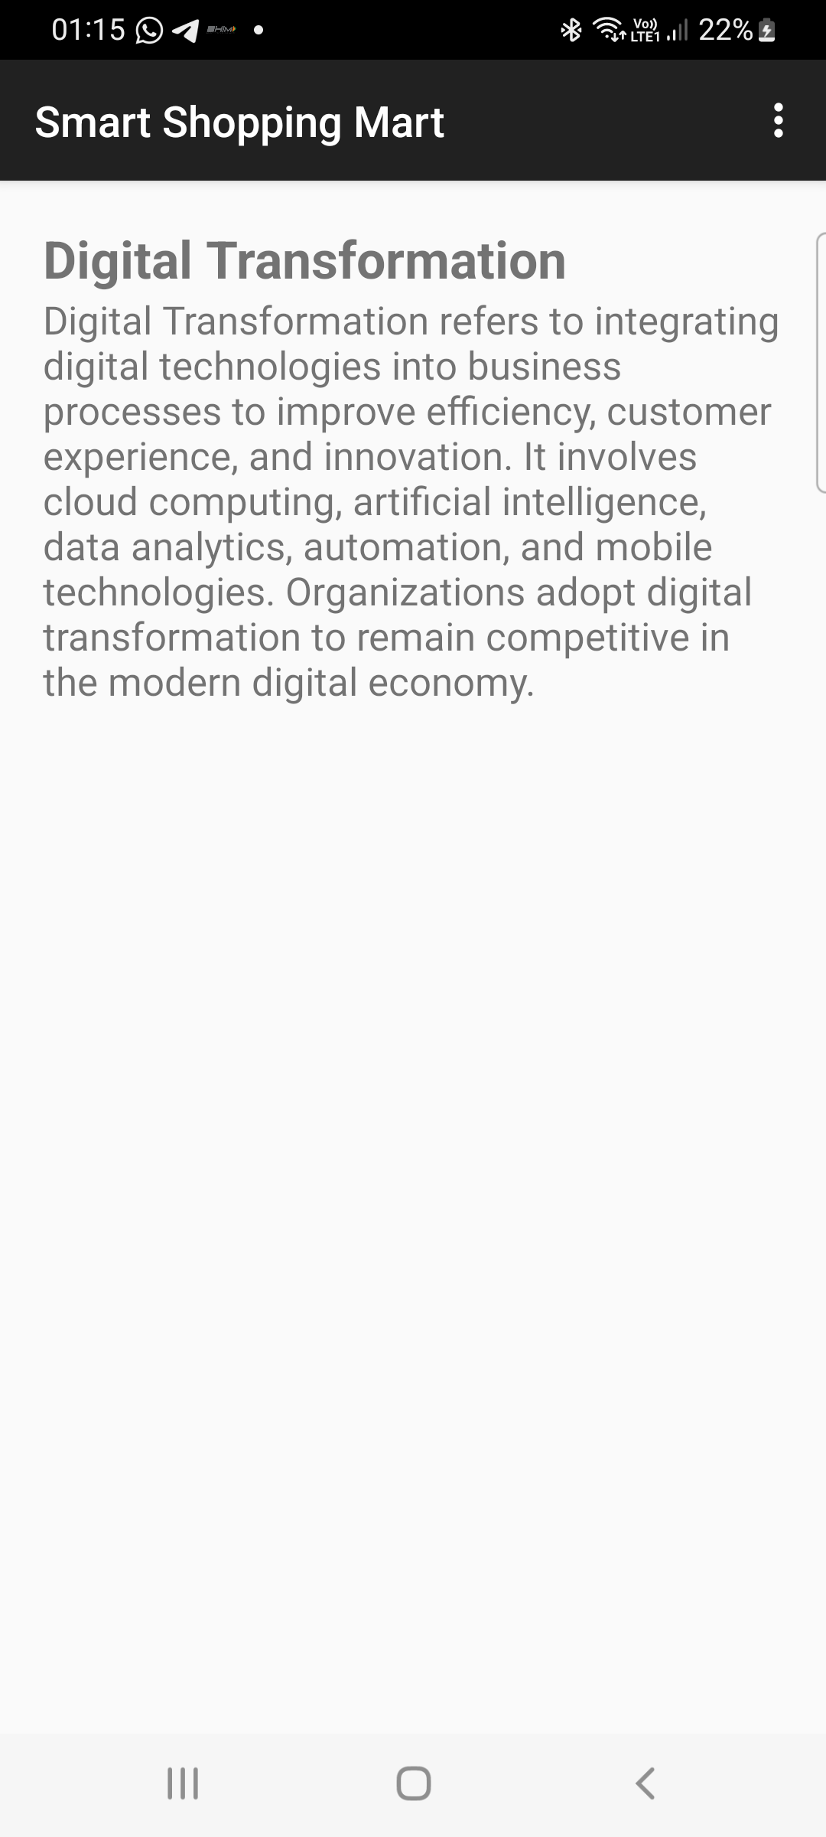

LAB NO. 8 :ANDROID SQLITE & SHARED PREFERENCES

- Write a program to create a "Task Manager" application with the following features: a) A form to create and save tasks with fields like task name, due date, and priority level (High, Medium, Low). b) A list view to display all the saved tasks with their details. c) An option to edit or delete any task from the list.

activity_main.xml
<?xml version="1.0" encoding="utf-8"?>
<LinearLayout xmlns:android="http://schemas.android.com/apk/res/android"
android:orientation="vertical"
android:padding="20dp"
android:layout_width="match_parent"
android:layout_height="match_parent">

<EditText
android:id="@+id/taskName"
android:hint="Task Name"
android:layout_width="match_parent"
android:layout_height="wrap_content"/>

<DatePicker
android:id="@+id/datePicker"
android:layout_width="match_parent"
android:layout_height="wrap_content"/>

<Spinner
android:id="@+id/prioritySpinner"
android:layout_width="match_parent"
android:layout_height="wrap_content"/>

<Button
android:id="@+id/addTask"
android:text="Save Task"
android:layout_width="match_parent"
android:layout_height="wrap_content"/>

<ListView
android:id="@+id/taskList"
android:layout_width="match_parent"
android:layout_height="wrap_content"/>

</LinearLayout>

task_item.xml
<LinearLayout xmlns:android="http://schemas.android.com/apk/res/android"
android:padding="10dp"
android:orientation="vertical"
android:layout_width="match_parent"
android:layout_height="wrap_content">

<TextView
android:id="@+id/taskText"
android:textSize="18sp"
android:layout_width="wrap_content"
android:layout_height="wrap_content"/>

</LinearLayout>

Task.java
package com.example.taskmanager;

public class Task {

String name;
String date;
String priority;

public Task(String name,String date,String priority){
this.name=name;
this.date=date;
this.priority=priority;
}

@Override
public String toString(){
return name + " | " + date + " | " + priority;
}
}

MainActivity.java:
package com.example.taskmanager;

import androidx.appcompat.app.AppCompatActivity;
import android.os.Bundle;
import android.widget.*;
import android.view.*;
import android.app.AlertDialog;
import java.util.*;

public class MainActivity extends AppCompatActivity {

EditText taskName;
Spinner prioritySpinner;
DatePicker datePicker;
Button addTask;
ListView taskList;

ArrayList<Task> tasks;
ArrayAdapter<Task> adapter;

String[] priorityLevels={"High","Medium","Low"};

@Override
protected void onCreate(Bundle savedInstanceState){

super.onCreate(savedInstanceState);
setContentView(R.layout.activity_main);

taskName=findViewById(R.id.taskName);
prioritySpinner=findViewById(R.id.prioritySpinner);
datePicker=findViewById(R.id.datePicker);
addTask=findViewById(R.id.addTask);
taskList=findViewById(R.id.taskList);

tasks=new ArrayList<>();

ArrayAdapter<String> spinnerAdapter=new ArrayAdapter<>
(this,android.R.layout.simple_spinner_dropdown_item,priorityLevels);

prioritySpinner.setAdapter(spinnerAdapter);

adapter=new ArrayAdapter<>(this,
android.R.layout.simple_list_item_1,tasks);

taskList.setAdapter(adapter);

addTask.setOnClickListener(v->{

String name=taskName.getText().toString();

int day=datePicker.getDayOfMonth();
int month=datePicker.getMonth()+1;
int year=datePicker.getYear();

String date=day+"/"+month+"/"+year;

String priority=prioritySpinner.getSelectedItem().toString();

tasks.add(new Task(name,date,priority));

adapter.notifyDataSetChanged();

taskName.setText("");

});

taskList.setOnItemLongClickListener((parent,view,position,id)->{

showOptions(position);
return true;
});

}

private void showOptions(int position){

String[] options={"Edit","Delete"};

new AlertDialog.Builder(this)
.setTitle("Task Options")
.setItems(options,(dialog,which)->{

if(which==0){
editTask(position);
}

if(which==1){
tasks.remove(position);
adapter.notifyDataSetChanged();
}

})
.show();
}

private void editTask(int position){

EditText input=new EditText(this);

input.setText(tasks.get(position).name);

new AlertDialog.Builder(this)
.setTitle("Edit Task")
.setView(input)
.setPositiveButton("Save",(d,w)->{

tasks.get(position).name=input.getText().toString();
adapter.notifyDataSetChanged();

})
.setNegativeButton("Cancel",null)
.show();
}
}

AndroidManifest.xml:
<manifest xmlns:android="http://schemas.android.com/apk/res/android"
package="com.example.taskmanager">

<application
android:label="Task Manager"
android:theme="@style/Theme.AppCompat.Light.DarkActionBar">

<activity android:name=".MainActivity">
<intent-filter>
<action android:name="android.intent.action.MAIN"/>
<category android:name="android.intent.category.LAUNCHER"/>
</intent-filter>
</activity>

</application>

</manifest>

UI:
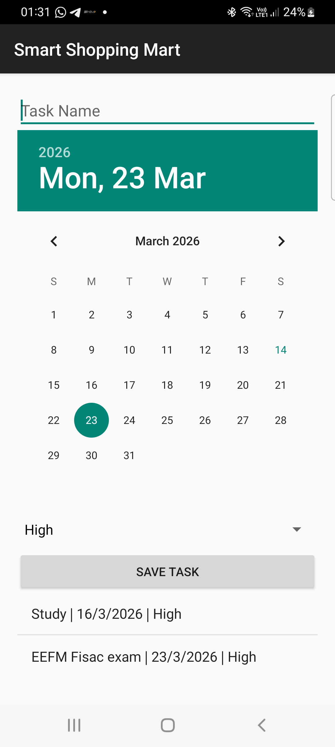
2. Write a program to add grocery items along with its cost into the database
and display the total cost of all the item selected by the user. Items has to be
displayed through spinner

Activity_main.xml:
<?xml version="1.0" encoding="utf-8"?>
<LinearLayout xmlns:android="http://schemas.android.com/apk/res/android"
android:orientation="vertical"
android:padding="20dp"
android:layout_width="match_parent"
android:layout_height="match_parent">

<EditText
android:id="@+id/itemName"
android:hint="Item Name"
android:layout_width="match_parent"
android:layout_height="wrap_content"/>

<EditText
android:id="@+id/itemCost"
android:hint="Item Cost"
android:inputType="numberDecimal"
android:layout_width="match_parent"
android:layout_height="wrap_content"/>

<Button
android:id="@+id/addItem"
android:text="Add Item"
android:layout_width="match_parent"
android:layout_height="wrap_content"/>

<Spinner
android:id="@+id/itemSpinner"
android:layout_width="match_parent"
android:layout_height="wrap_content"/>

<Button
android:id="@+id/addToCart"
android:text="Add To Cart"
android:layout_width="match_parent"
android:layout_height="wrap_content"/>

<TextView
android:id="@+id/totalCost"
android:text="Total Cost: 0"
android:textSize="20sp"
android:layout_marginTop="20dp"
android:layout_width="wrap_content"
android:layout_height="wrap_content"/>

</LinearLayout>

DBHelper.java
package com.example.groceryapp;

import android.content.*;
import android.database.*;
import android.database.sqlite.*;

public class DBHelper extends SQLiteOpenHelper {

public static final String DB_NAME = "GroceryDB";
public static final String TABLE_NAME = "items";

public DBHelper(Context context) {
super(context, DB_NAME, null, 1);
}

@Override
public void onCreate(SQLiteDatabase db) {

db.execSQL("CREATE TABLE items(id INTEGER PRIMARY KEY AUTOINCREMENT, name TEXT, cost REAL)");
}

@Override
public void onUpgrade(SQLiteDatabase db, int oldVersion, int newVersion) {

db.execSQL("DROP TABLE IF EXISTS items");
onCreate(db);
}

public void insertItem(String name, double cost){

SQLiteDatabase db=this.getWritableDatabase();

ContentValues cv=new ContentValues();
cv.put("name",name);
cv.put("cost",cost);

db.insert(TABLE_NAME,null,cv);
}

public Cursor getItems(){

SQLiteDatabase db=this.getReadableDatabase();
return db.rawQuery("SELECT * FROM items",null);
}

public double getCost(String name){

SQLiteDatabase db=this.getReadableDatabase();

Cursor c=db.rawQuery("SELECT cost FROM items WHERE name=?",new String[]{name});

if(c.moveToFirst()){
return c.getDouble(0);
}

return 0;
}
}
MainActivity.java:
package com.example.groceryapp;

import androidx.appcompat.app.AppCompatActivity;
import android.os.Bundle;
import android.widget.*;
import android.database.Cursor;
import java.util.*;

public class MainActivity extends AppCompatActivity {

EditText itemName,itemCost;
Button addItem,addToCart;
Spinner itemSpinner;
TextView totalCost;

DBHelper db;

ArrayList<String> items;
ArrayAdapter<String> adapter;

double total=0;

@Override
protected void onCreate(Bundle savedInstanceState) {

super.onCreate(savedInstanceState);
setContentView(R.layout.activity_main);

itemName=findViewById(R.id.itemName);
itemCost=findViewById(R.id.itemCost);
addItem=findViewById(R.id.addItem);
addToCart=findViewById(R.id.addToCart);
itemSpinner=findViewById(R.id.itemSpinner);
totalCost=findViewById(R.id.totalCost);

db=new DBHelper(this);

items=new ArrayList<>();

loadItems();

addItem.setOnClickListener(v->{

String name=itemName.getText().toString();
double cost=Double.parseDouble(itemCost.getText().toString());

db.insertItem(name,cost);

Toast.makeText(this,"Item Added",Toast.LENGTH_SHORT).show();

itemName.setText("");
itemCost.setText("");

loadItems();
});

addToCart.setOnClickListener(v->{

String selected=itemSpinner.getSelectedItem().toString();

double price=db.getCost(selected);

total+=price;

totalCost.setText("Total Cost: "+total);

});

}

private void loadItems(){

items.clear();

Cursor c=db.getItems();

while(c.moveToNext()){
items.add(c.getString(1));
}

adapter=new ArrayAdapter<>(this,
android.R.layout.simple_spinner_dropdown_item,items);

itemSpinner.setAdapter(adapter);
}
}
AndroidManifest.xml:
<manifest xmlns:android="http://schemas.android.com/apk/res/android"
package="com.example.groceryapp">

<application
android:label="Grocery App"
android:theme="@style/Theme.AppCompat.Light.DarkActionBar">

<activity android:name=".MainActivity">
<intent-filter>
<action android:name="android.intent.action.MAIN"/>
<category android:name="android.intent.category.LAUNCHER"/>
</intent-filter>
</activity>

</application>

</manifest>
UI:
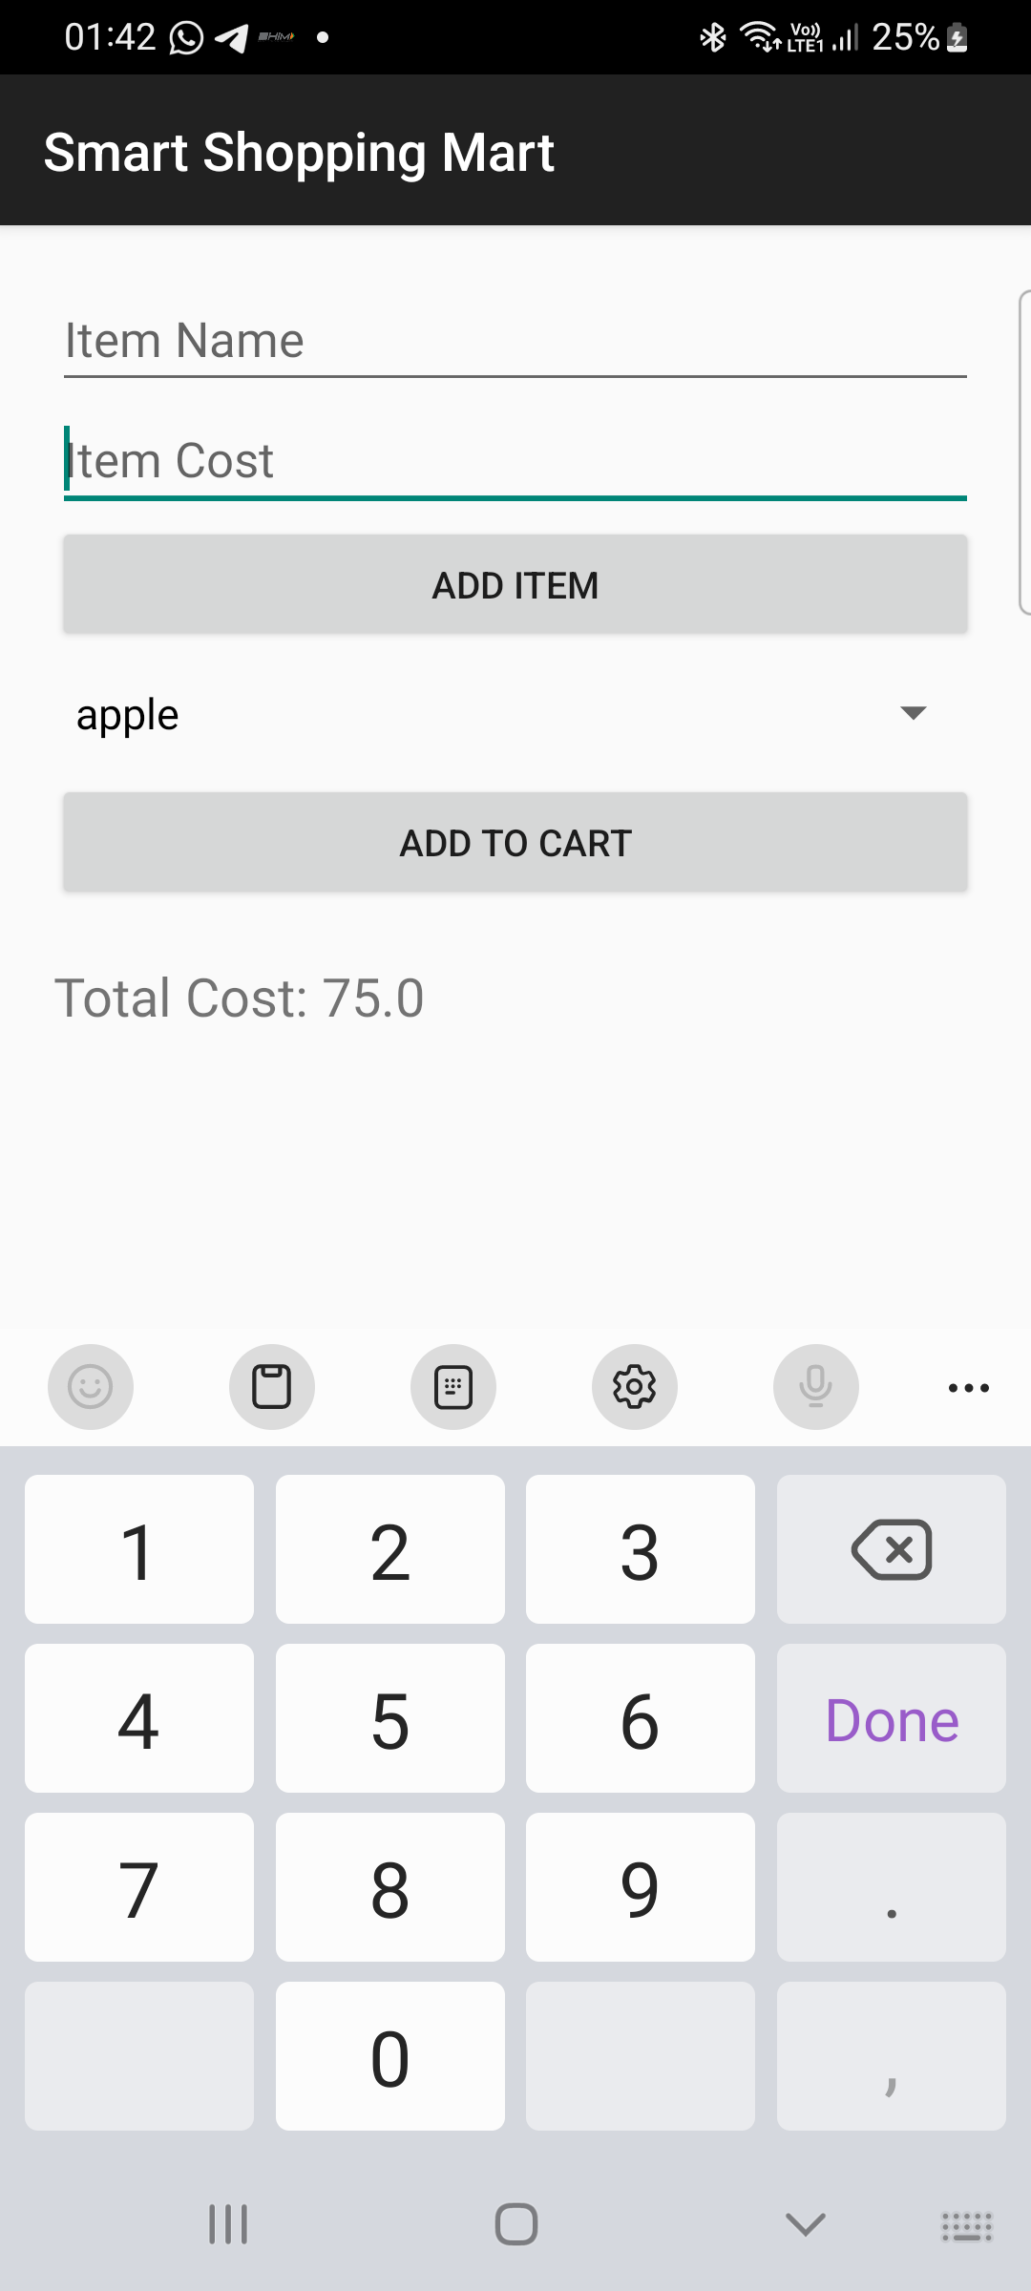

3. Create an application “Movie Review” to create a movie review to do the following:
a) User can write a movie review by stating movie name, year,giving points
ranging from 1-5 and save details in a database.
b) User can view the movie review for which review are already defined
.Movie names has to be displayed using listview,and the selected movie’s
details should be displayed in a table

Activity_main.xml:
<?xml version="1.0" encoding="utf-8"?>
<LinearLayout xmlns:android="http://schemas.android.com/apk/res/android"
android:orientation="vertical"
android:padding="20dp"
android:layout_width="match_parent"
android:layout_height="match_parent">

<EditText
android:id="@+id/movieName"
android:hint="Movie Name"
android:layout_width="match_parent"
android:layout_height="wrap_content"/>

<EditText
android:id="@+id/movieYear"
android:hint="Year"
android:inputType="number"
android:layout_width="match_parent"
android:layout_height="wrap_content"/>

<Spinner
android:id="@+id/ratingSpinner"
android:layout_width="match_parent"
android:layout_height="wrap_content"/>

<Button
android:id="@+id/saveReview"
android:text="Save Review"
android:layout_width="match_parent"
android:layout_height="wrap_content"/>

<TextView
android:text="Movie Reviews"
android:textSize="20sp"
android:layout_marginTop="20dp"
android:layout_width="wrap_content"
android:layout_height="wrap_content"/>

<ListView
android:id="@+id/movieList"
android:layout_width="match_parent"
android:layout_height="200dp"/>

<TableLayout
android:id="@+id/movieTable"
android:layout_width="match_parent"
android:layout_height="wrap_content"
android:layout_marginTop="10dp"/>

</LinearLayout>

DBHelper.java:
package com.example.moviereview;

import android.content.*;
import android.database.*;
import android.database.sqlite.*;

public class DBHelper extends SQLiteOpenHelper {

public static final String DB_NAME = "MovieDB";

public DBHelper(Context context){
super(context, DB_NAME, null, 1);
}

@Override
public void onCreate(SQLiteDatabase db) {

db.execSQL("CREATE TABLE movies(id INTEGER PRIMARY KEY AUTOINCREMENT, name TEXT, year TEXT, rating INTEGER)");
}

@Override
public void onUpgrade(SQLiteDatabase db,int oldVersion,int newVersion){

db.execSQL("DROP TABLE IF EXISTS movies");
onCreate(db);
}

public void insertMovie(String name,String year,int rating){

SQLiteDatabase db=this.getWritableDatabase();

ContentValues cv=new ContentValues();
cv.put("name",name);
cv.put("year",year);
cv.put("rating",rating);

db.insert("movies",null,cv);
}

public Cursor getMovies(){

SQLiteDatabase db=this.getReadableDatabase();
return db.rawQuery("SELECT * FROM movies",null);
}

public Cursor getMovieDetails(String name){

SQLiteDatabase db=this.getReadableDatabase();
return db.rawQuery("SELECT * FROM movies WHERE name=?",new String[]{name});
}
}

MainActivity.java:
package com.example.moviereview;

import androidx.appcompat.app.AppCompatActivity;
import android.os.Bundle;
import android.widget.*;
import android.database.Cursor;
import android.view.*;
import java.util.*;

public class MainActivity extends AppCompatActivity {

EditText movieName,movieYear;
Spinner ratingSpinner;
Button saveReview;
ListView movieList;
TableLayout movieTable;

DBHelper db;

ArrayList<String> movies;
ArrayAdapter<String> adapter;

String[] ratings={"1","2","3","4","5"};

@Override
protected void onCreate(Bundle savedInstanceState){

super.onCreate(savedInstanceState);
setContentView(R.layout.activity_main);

movieName=findViewById(R.id.movieName);
movieYear=findViewById(R.id.movieYear);
ratingSpinner=findViewById(R.id.ratingSpinner);
saveReview=findViewById(R.id.saveReview);
movieList=findViewById(R.id.movieList);
movieTable=findViewById(R.id.movieTable);

db=new DBHelper(this);

ArrayAdapter<String> spinnerAdapter=new ArrayAdapter<>
(this,android.R.layout.simple_spinner_dropdown_item,ratings);

ratingSpinner.setAdapter(spinnerAdapter);

movies=new ArrayList<>();

loadMovies();

saveReview.setOnClickListener(v->{

String name=movieName.getText().toString();
String year=movieYear.getText().toString();
int rating=Integer.parseInt(ratingSpinner.getSelectedItem().toString());

db.insertMovie(name,year,rating);

Toast.makeText(this,"Review Saved",Toast.LENGTH_SHORT).show();

movieName.setText("");
movieYear.setText("");

loadMovies();
});

movieList.setOnItemClickListener((parent,view,position,id)->{

String selected=movies.get(position);

showDetails(selected);
});

}

private void loadMovies(){

movies.clear();

Cursor c=db.getMovies();

while(c.moveToNext()){
movies.add(c.getString(1));
}

adapter=new ArrayAdapter<>(this,
android.R.layout.simple_list_item_1,movies);

movieList.setAdapter(adapter);
}

private void showDetails(String name){

movieTable.removeAllViews();

Cursor c=db.getMovieDetails(name);

if(c.moveToFirst()){

TableRow row1=new TableRow(this);
TextView t1=new TextView(this);
t1.setText("Movie:");
TextView t2=new TextView(this);
t2.setText(c.getString(1));
row1.addView(t1);
row1.addView(t2);

TableRow row2=new TableRow(this);
TextView t3=new TextView(this);
t3.setText("Year:");
TextView t4=new TextView(this);
t4.setText(c.getString(2));
row2.addView(t3);
row2.addView(t4);

TableRow row3=new TableRow(this);
TextView t5=new TextView(this);
t5.setText("Rating:");
TextView t6=new TextView(this);
t6.setText(c.getString(3));
row3.addView(t5);
row3.addView(t6);

movieTable.addView(row1);
movieTable.addView(row2);
movieTable.addView(row3);
}
}
}
AndroidManifest.xml:
<manifest xmlns:android="http://schemas.android.com/apk/res/android"
package="com.example.moviereview">

<application
android:label="Movie Review"
android:theme="@style/Theme.AppCompat.Light.DarkActionBar">

<activity android:name=".MainActivity">
<intent-filter>
<action android:name="android.intent.action.MAIN"/>
<category android:name="android.intent.category.LAUNCHER"/>
</intent-filter>
</activity>

</application>

</manifest>

UI:
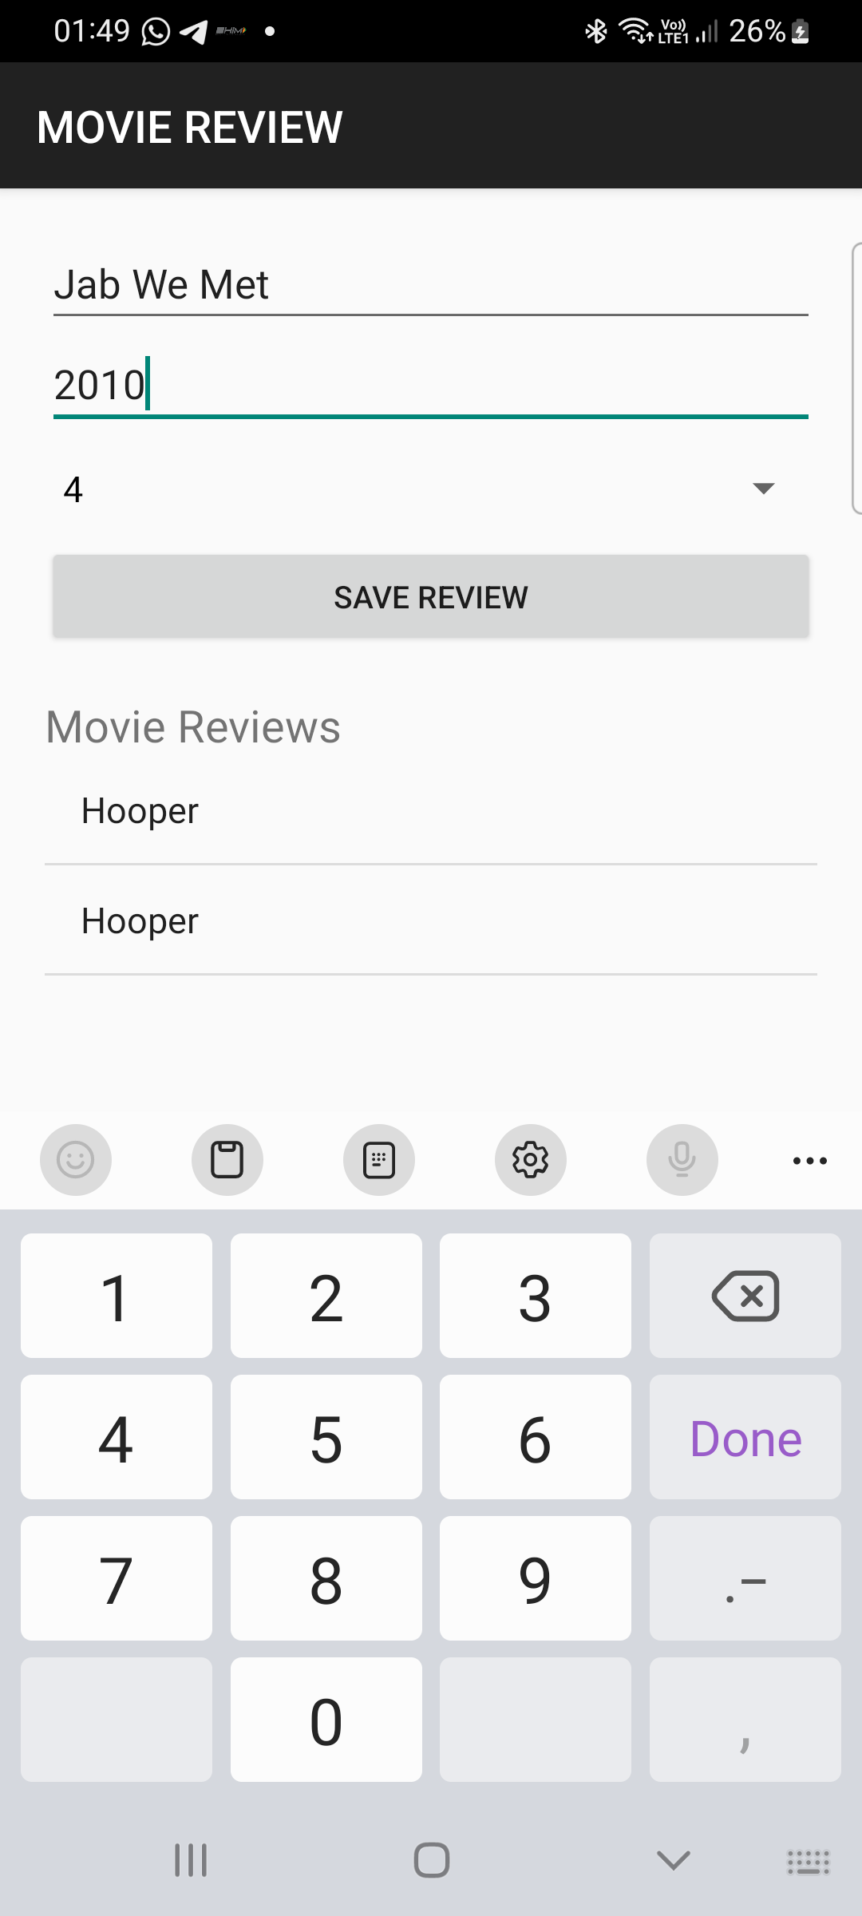

4. Make use of SQLite browser to view the database, tables created. Modify the
tables and upload the same into your project and view the modified data
through your app

AndroidManifest.xml
<?xml version="1.0" encoding="utf-8"?>
<manifest xmlns:android="http://schemas.android.com/apk/res/android"
package="com.example.myapplication">

<application
android:allowBackup="true"
android:label="Student Database"
android:theme="@style/Theme.AppCompat.Light.DarkActionBar">

<activity android:name=".MainActivity">
<intent-filter>
<action android:name="android.intent.action.MAIN"/>
<category android:name="android.intent.category.LAUNCHER"/>
</intent-filter>
</activity>

</application>
</manifest>

activity_main.xml
<LinearLayout xmlns:android="http://schemas.android.com/apk/res/android"
android:orientation="vertical"
android:padding="16dp"
android:layout_width="match_parent"
android:layout_height="match_parent">

<TextView
android:text="Student Records"
android:textSize="22sp"
android:textStyle="bold"
android:layout_width="wrap_content"
android:layout_height="wrap_content"/>

<ListView
android:id="@+id/listStudents"
android:layout_width="match_parent"
android:layout_height="match_parent"/>

</LinearLayout>

DBHelper.java
package com.example.myapplication;

import android.content.Context;
import android.database.sqlite.SQLiteDatabase;
import android.database.sqlite.SQLiteOpenHelper;

public class DBHelper extends SQLiteOpenHelper {

public DBHelper(Context context) {
super(context, "studentDB", null, 1);
}

@Override
public void onCreate(SQLiteDatabase db) {

db.execSQL("CREATE TABLE student(id INTEGER PRIMARY KEY, name TEXT, course TEXT)");

db.execSQL("INSERT INTO student VALUES(1,'Riya','Android')");
db.execSQL("INSERT INTO student VALUES(2,'Rahul','Java')");
db.execSQL("INSERT INTO student VALUES(3,'Ankit','Python')");
}

@Override
public void onUpgrade(SQLiteDatabase db, int oldVersion, int newVersion) {

}
}

MainActivity.java
package com.example.myapplication;

import android.database.Cursor;
import android.database.sqlite.SQLiteDatabase;
import android.os.Bundle;
import android.widget.ArrayAdapter;
import android.widget.ListView;

import androidx.appcompat.app.AppCompatActivity;

import java.util.ArrayList;

public class MainActivity extends AppCompatActivity {

ListView listView;

protected void onCreate(Bundle savedInstanceState) {
super.onCreate(savedInstanceState);
setContentView(R.layout.activity_main);

listView = findViewById(R.id.listStudents);

DBHelper helper = new DBHelper(this);
SQLiteDatabase db = helper.getReadableDatabase();

Cursor cursor = db.rawQuery("SELECT * FROM student", null);

ArrayList<String> list = new ArrayList<>();

while(cursor.moveToNext()){

list.add(
cursor.getInt(0)+" "+
cursor.getString(1)+" "+
cursor.getString(2)
);
}

ArrayAdapter adapter = new ArrayAdapter(
this,
android.R.layout.simple_list_item_1,
list);

listView.setAdapter(adapter);
}
}

UI:

5. Demonstrates the use of the Shared Preferences through an android
application which displays a screen with some text fields. Save the value when
the application is closed and brought back when it is opened again

Activity_main.xml:
<?xml version="1.0" encoding="utf-8"?>
<LinearLayout xmlns:android="http://schemas.android.com/apk/res/android"
android:orientation="vertical"
android:padding="20dp"
android:layout_width="match_parent"
android:layout_height="match_parent">

<EditText
android:id="@+id/name"
android:hint="Enter Name"
android:layout_width="match_parent"
android:layout_height="wrap_content"/>

<EditText
android:id="@+id/email"
android:hint="Enter Email"
android:layout_width="match_parent"
android:layout_height="wrap_content"/>

<EditText
android:id="@+id/phone"
android:hint="Enter Phone"
android:inputType="phone"
android:layout_width="match_parent"
android:layout_height="wrap_content"/>

<Button
android:id="@+id/saveBtn"
android:text="Save"
android:layout_width="match_parent"
android:layout_height="wrap_content"/>

</LinearLayout>

MainAcitvity.java:
package com.example.sharedpreferencesdemo;

import androidx.appcompat.app.AppCompatActivity;
import android.os.Bundle;
import android.widget.*;
import android.content.SharedPreferences;

public class MainActivity extends AppCompatActivity {

EditText name,email,phone;
Button saveBtn;

SharedPreferences preferences;

@Override
protected void onCreate(Bundle savedInstanceState) {

super.onCreate(savedInstanceState);
setContentView(R.layout.activity_main);

name=findViewById(R.id.name);
email=findViewById(R.id.email);
phone=findViewById(R.id.phone);
saveBtn=findViewById(R.id.saveBtn);

preferences=getSharedPreferences("UserData",MODE_PRIVATE);

//Load saved data
name.setText(preferences.getString("name",""));
email.setText(preferences.getString("email",""));
phone.setText(preferences.getString("phone",""));

saveBtn.setOnClickListener(v -> saveData());
}

private void saveData(){

SharedPreferences.Editor editor=preferences.edit();

editor.putString("name",name.getText().toString());
editor.putString("email",email.getText().toString());
editor.putString("phone",phone.getText().toString());

editor.apply();

Toast.makeText(this,"Data Saved",Toast.LENGTH_SHORT).show();
}

@Override
protected void onPause() {

super.onPause();
saveData(); //save automatically when app closes
}
}
AndroidManifest.xml:
<manifest xmlns:android="http://schemas.android.com/apk/res/android"
package="com.example.sharedpreferencesdemo">

<application
android:label="SharedPreferences Demo"
android:theme="@style/Theme.AppCompat.Light.DarkActionBar">

<activity android:name=".MainActivity">
<intent-filter>
<action android:name="android.intent.action.MAIN"/>
<category android:name="android.intent.category.LAUNCHER"/>
</intent-filter>
</activity>

</application>

</manifest>

UI:
